

**A**

**MAJOR PROJECT REPORT**

**ON**

**“Billing System”**

BY

## Miss. Mahajan Pallavi Jagannath

Submitted in Partial fulfillment of **Master of Computer Application**Savitribai Phule Pune University

For the Academic Year 2023-2024

Under The Guidance of

## Prof. P. D. Jadhav

## MET Institute of Engineering

## Bhujbal Knowledge City

## Adgaon , Nashik

## SAVITRIBAI PHULE PUNE UNIVERSITY



**A**

**MAJOR PROJECT REPORT**

**ON**

**“Billing System”**

BY

## Miss. Mahajan Pallavi Jagannath

Submitted in Partial fulfillment of **Master of Computer Application**Savitribai Phule Pune University

For the Academic Year 2023-2024

Under The Guidance of

## Prof. P. D. Jadhav

## Department of MCA

## MET Institute of Engineering

## Bhujbal Knowledge City

## Adgaon , Nashik



**Department of Master of Computer Application**

Affiliated to

**Savitribai Phule Pune University**

**CERTIFICATE**

**This is to certify that Major project entitled**

“ **Billing System** ”

Has been satisfactorily Completed by

**Mahajan Pallavi Jagannath**

In partial fulfillment of Major Project Work for

**Degree In Master of Computer Application Under the Faculty of Engineering**

**Prof. P. D. Jadhav Prof. P. D. Jadhav (Project Guide) (**H.O.D**)**

**Signed By Dr. V. P. Wani**

**(External Examiner) (Principal)**

**Place :** Nashik

**Date :** / /

## Joining Letter

## 

## Internship Certificate

## 

## 

## ACKNOWLEDGEMENT

The success and final outcome of this project required substantial guidance and assistance from many people, and I am extremely fortunate to have received this support throughout the completion of my project work. Whatever I have accomplished is due to such guidance and assistance, and I would like to extend my heartfelt thanks to everyone involved.

I would like to express my sincere gratitude to **Mr. Shubham** **Jathar** for giving me the opportunity to undertake the project work on the Billing System and for providing all the support and guidance necessary to complete the project on time. I am extremely grateful for his unwavering support and guidance despite his busy schedule managing the company's affairs.

I owe my profound gratitude to our project guide, **Mrs. Amruta Aware** , who showed great interest in our project work and guided us throughout the entire process. Her valuable insights and constant support were instrumental in the successful completion of our project.

**Prof. P.D. Jadhav** (Project Guide)

(HOD of MCA, MET BKC IOE College, Nashik)

I would like to thank him for his qualified guidance, valuable suggestions, and constant encouragement throughout the course and project. His insightful feedback and dedicated support were crucial in navigating the challenges and successfully completing the project. His expertise and commitment greatly contributed to my learning experience and the overall success of this work.

Prof. Nita Shinde

(Professor in MET BKC IOE College ,Nashik)

I would like to thank Prof. Nita Shinde for her qualified guidance, valuable suggestions, and constant encouragement throughout the course and project. Her insightful feedback and unwavering support have been instrumental in shaping the direction and quality of my work. I also appreciate her valuable time and help with my documentation, ensuring its clarity and coherence. Her dedication to fostering a positive learning environment and her willingness to go above and beyond to assist students have been truly inspiring.

Prof. Manjusha Khond

(Professor in MET BKC IOE College ,Nashik)

I would like to thank Prof. Manjusha Khond for her qualified guidance, valuable suggestions and constant encouragement throughout the course and project and also for giving her valuable time and help for my documentation.

**Pallavi Mahajan**

## 

## ABSTRACT

The billing system presented herein is a comprehensive web-based platform designed to streamline financial transactions for businesses. In today's digital age, efficient management of billing processes is crucial for optimizing operations and ensuring financial transparency. This system aims to address the complexities associated with invoicing, payment tracking, and expense management by providing a centralized platform accessible from anywhere with internet connectivity.

Key functionalities of the billing system include automated invoicing, customizable billing templates, secure payment processing, and detailed reporting capabilities. By automating repetitive tasks and reducing manual errors, the system enhances accuracy and efficiency in financial operations. Additionally, the system incorporates a transportation feature, enabling businesses to manage logistics and transportation costs seamlessly.

Through its user-friendly interface, the billing system empowers businesses to manage their billing cycles effectively, from generating invoices to tracking payments and analyzing financial performance. By leveraging digital technology, this system not only streamlines billing processes but also contributes to overall business productivity and growth.

**Contents**

1 INTRODUCTION 13

1.1 Company Profile 13

1.2 Company providing following services 14

1.3 Existing System 14

1.4 Need of System 15

1.5 Problem Statement 16

1.6 Project Objectives 16

1.7 Scope of System 16

1.8 Operating Environment 17

1.9 Detail Description Of Technology 18

1.9.1 Java: 18

1.9.2 Java Servlets: 20

1.9.3 Apache Tomcat Server: 21

1.9.4 HTML (Hyper Text Markup Language): 21

1.9.5 CSS (Cascading Style Sheets): 23

1.9.6 JavaScript: 24

1.9.7 Bootstrap: 25

1.10 Connecting a Java application to a MySQL: 25

1.11 Introduction to MySQL 26

2 Proposed System 29

2.1 Proposed system 29

2.2 Modules: 29

2.2 .1 Product Module: 29

2.2.2 Order Module: 30

2.2.3 Stock Module: 30

2.2.4 Transport Module: 30

2.2.5 Invoice Module: 30

2.2.5 Sales Module: 30

2.3 Objective of the System: 31

2.4 Feasibility Study: 31

2.4.1 Technical Feasibility 32

2.4.2 Operational Feasibility 32

2.4.3 Economic Feasibility 33

2.5 Security 33

2.6 User Requirements 33

2.7 Requirement Analysis 34

3 System Design 38

3.1 Entity Relationship Diagram 38

3.2 Data Flow Diagram 39

3.3 Use Case Diagram 40

3.4 Class Diagram 41

3.5 Activity Diagram 41

3.5.1 Add client 42

3.5.2 View Invoice 43

3.6 Sequence Diagrams 44

3.7 Component Diagrams 45

3.8 Deployment Diagram 46

3.9 Data Dictionary 47

4 Test Procedure and Implementation 50

4.1. Preparation and Planning 50

4.1.1 Define Objectives 50

4.1.2 Develop a Test Plan 50

4.1.3 Identify Test Items 50

4.1.4 Risk Analysis 50

4.2. Designing Tests 50

4.2.1 Create Test Cases 51

4.2.2 Develop Test Scripts 52

4.2.3 Prepare Test Data 52

4.3. Setting Up the Test Environment 52

4.3.1 Configure Test Environment 53

4.3.2 Verify Environment Readiness 53

4.4. Executing Tests 53

4.4.1 Perform Tests 53

4.4.2 Monitor Testing 53

4.5. Analyzing Results 53

4.5.1 Evaluate Test Results 53

4.5.2 Perform Root Cause Analysis 53

4.6. Reporting 53

4.6.1 Document Findings 53

4.6.2 Communicate Results 54

4.7. Post-Testing Activities 54

4.7.1 Retesting and Regression Testing 54

4.7.2 Test Closure 54

4.8. Continuous Improvement 54

4.8.1 Analyze Metrics 54

4.8.2 Update Test Plan 54

5 SCREENSHOT 55

5.1 Login: 55

5.2 Home Page: 56

5.3 Vertical Navigation Bar: 56

5.4 Product Page: 57

5.5 Product Validation: 57

5.6 Add Product : 58

5.7 Product List: 58

5.8 Stock Detail: 59

5.9 Stock List: 59

5.10 Monthly Sales: 60

5.11 Monthly Sales List: 60

5.12 Order Page: 61

5.13 Add Order: 61

5.14 oder List : 62

5.15 Delete Order : 62

5.16 Add Trensport: 63

5.17 Transport List: 63

5.18 Invoice List: 64

5.19 Invoice : 64

5.20 Download Invoice : 65

5.21 Add Client: 65

5.22 Client List: 66

5.23 Logout: 66

6 Limitations and Future Enhancement 67

6.1 Limitations: 67

6.2 Future Enhancement 67

6.2.1 Mobile and Cloud Integration 67

6.2.2 Customer Self-Service Portals 68

7 CONCLUSION 69

8 BIBLIOGRAPHY AND REFERENCE 70

8.1 Books Used: 70

8.2 References Used: 70

**List of Figures**

Figure 1 Entity Relationship Diagram 38

Figure 2 Data Flow Diagram 39

Figure 3 Use Case Diagram 40

Figure 4 Class Diagram 41

Figure 5.1 Add client 42

Figure 5.2 View Invoice 43

Figure 6 Sequence Diagrams 44

Figure 7 Component Diagrams 45

Figure 8 Deployment Diagram 46

Figure 9 Clients 47

Figure 10 Order Data 47

Figure 11 Products 48

Figure 12 Stocks 48

Figure 13 Transport Detail 49

Figure 14 Test case For User Login 51

Figure 15 Test case For Add Product 52

Figure 16 Login 55

Figure 17 Home Page 56

Figure 18 Vertical Navigation Bar 56

Figure 19 Product Page 57

Figure 20 Product Validation 57

Figure 21 Add Product 58

Figure 22 Product List 58

Figure 23 Stock Detail 59

Figure 24 Stock List 59

Figure 25 Monthly Sales 60

Figure 26 Monthly Sales List 60

Figure 27 Order Page 61

Figure 28 Add Order 61

Figure 29 order List 62

Figure 30 Delete Order 62

Figure 31 Add Trensport 63

Figure 32 Transport List 63

Figure 33 Invoice List 64

Figure 34 Invoice 64

Figure 35 Download Invoice 65

Figure 36 Add Client 65

Figure 37 Client List 66

Figure 38 Logout 66

**Chapter 1**

# **INTRODUCTION**

## Company Profile

## 

Telphatech is a software company founded in 2023, dedicated to empowering businesses with innovative technology solutions. Their team of experienced developers and designers focuses on creating custom software that addresses real-world problems and drives business growth. Telphatech's offerings include a wide range of services such as custom software development, web and mobile app development, IT consulting, UI/UX design, data analytics, e-commerce solutions, and ongoing support and maintenance​ .

The company is committed to a human-centered approach, prioritizing user needs and ensuring their solutions are accessible, intuitive, and user-friendly. Their vision is to provide reliable, innovative solutions while fostering long-term partnerships with clients. Telphatech values creativity, adaptability, and comprehensive solutions, aiming to make a significant impact through technology ​.

Telphatech also offers various products under different sub-brands like TelphaJobs for job searches, TelphaLearn for educational resources, and TelphaVision for career guidance. These products are designed to enhance user experience and provide practical solutions in their respective fields​​.

## 1.2 Company providing following services

Telphatech is a technology company that offers a wide range of services aimed at helping businesses leverage the power of digital solutions. Founded in 2023, the company focuses on providing innovative and user-friendly technology solutions tailored to meet specific business needs. Their key services include:

1. **Custom Software Development**: Creating tailored software solutions to address unique business challenges.
2. **Web Development**: Designing and developing user-friendly websites and web applications.
3. **Mobile App Development**: Developing mobile applications for both iOS and Android platforms.
4. **IT Consulting**: Offering expert advice on technology transformation and implementation.
5. **UI/UX Design**: Crafting optimized and user-centric digital experiences.
6. **Data Analytics**: Providing insights and data-driven solutions for better decision-making.
7. **E-commerce Solutions**: Delivering comprehensive online store solutions from development to maintenance.
8. **Support and Maintenance**: Offering ongoing assistance to ensure seamless operation of IT systems​​.

Additionally, Telphatech is involved in product development, with offerings such as TelphaChoice, TelphaJobs, TelphaLearn, TelphaView, and TelphaVision, which aim to enhance job searching, learning, interview preparation, and career planning​ ​.

## 1.3 Existing System

The existing manual system at the academy faced numerous challenges and inefficiencies, including:

1. **Inconvenient Process for Students**: Students had to visit the academy in person to fill out and submit inquiry forms, which was time-consuming and inconvenient, especially for those living far from the academy.
2. **Manual Enrollment**: After submitting the inquiry form, students had to wait for manual processing and enrollment into courses. This process often led to delays and errors, making it inefficient.
3. **Paper-Based Record Keeping**: All student records were maintained in physical files, making the retrieval, organization, and management of data cumbersome. This system was prone to misplacement or loss of documents, which could affect record accuracy and accessibility.
4. **High Costs for Printed Materials**: The academy provided printed notes to students, incurring high costs and leading to significant paper consumption. This practice raised environmental concerns due to the excessive use of paper and associated waste.

## 1.4 Need of System

The billing system serves as an open platform catering to the needs of businesses and individuals alike, providing an efficient and transparent method for managing financial transactions. It offers a user-friendly interface accessible to all, enabling users to generate invoices, track payments, and manage expenses with ease. For businesses, the system provides detailed information on billing procedures, including customizable templates and automated invoicing features. It also offers training sessions upon request, scheduled by billing administrators, to ensure users are proficient in utilizing the system's functionalities. Additionally, the system collaborates with external entities, such as financial institutions and regulatory bodies, to provide real-time updates on market trends, regulatory changes, and best practices in billing management. This comprehensive approach ensures that users, whether individuals or businesses, have access to up-to-date information and tools necessary for efficient financial management.

## 

## 1.5 Problem Statement

Inefficient billing processes pose significant challenges for businesses, leading to delays, errors, and financial discrepancies. Manual invoicing and payment tracking are time-consuming, prone to errors, and lack real-time insights into financial performance. Moreover, traditional billing methods often lack flexibility and scalability, hindering businesses' ability to adapt to changing market dynamics and customer needs. These inefficiencies result in increased administrative burden, delayed payments, and decreased customer satisfaction. Therefore, there is a pressing need for a comprehensive billing system that automates invoicing, streamlines payment processing, and provides actionable insights to optimize financial management processes. Such a system should be user-friendly, customizable, and capable of integrating with existing business systems to enhance efficiency, accuracy, and transparency in billing operations.

## 1.6 Project Objectives

* Automate invoicing processes to reduce manual effort and errors.
* Implement secure payment processing for timely recording of payments.
* Provide customizable billing templates for branding and flexibility.
* Design a user-friendly interface for ease of use.
* Develop a scalable system to accommodate business growth.
* Offer comprehensive training and support for users.
* Continuously gather feedback for system improvement.

## 

## 1.7 Scope of System

**Scope:**

* The billing system will cover automated invoicing, payment processing, and reporting functionalities.
* It will support customizable billing templates and real-time reporting for financial insights.
* Integration with existing business systems, such as accounting software, will be included.
* The system will prioritize user-friendly interface design and scalability for long-term viability.

## 1.8 Operating Environment

The billing system will operate in a web-based environment, accessible through standard web browsers such as Chrome, Firefox, Safari, and Edge. It will be compatible with major operating systems including Windows, macOS, and Linux. Users will access the system via desktop computers, laptops, tablets, and smartphones with internet connectivity. The system will leverage cloud-based infrastructure to ensure scalability, reliability, and accessibility from any location. It will adhere to industry-standard security protocols to protect sensitive financial data and ensure compliance with relevant regulations. Additionally, the system will support integration with existing business systems and third-party services through APIs or standardized data formats, enabling seamless data exchange and interoperability.

**Software Requirements:**

• Operating System: Windows 7, 8, 10,11 , Linux

• Development Tools: Visual Studio Code

• Scripting / Server Side Language: Java with Java Servlets on Apache Tomcat Server 10

• Front-End Language: HTML ,CSS , JavaScript, Bootstrap

• Database: MYSQL

**Hardware Requirement :**

**• Server:**

Processor : Pentium Dual Core Or Pentium 4 and above

RAM : 2 GB

HDD : 80 GB

Connection : 24 * 7 Internet Connection

**• Client:**

Processor : i3 Processor and above

RAM : 4 GB HDD : 80 GB

Connection : Internet Connection

## 1.9 Detail Description Of Technology

### **1.9.1 Java:**

Java is a widely-used, class-based, object-oriented programming language developed by Sun Microsystems (now owned by Oracle Corporation). It is designed to have minimal implementation dependencies, making it suitable for writing once and running anywhere. Java offers platform independence, robustness, and extensive libraries for various applications, including web development. It is commonly used for building enterprise-scale applications, web servers, mobile applications (Android), and large-scale distributed systems.

### **Key Features of Java**

1. **Platform Independence**: Java programs are compiled into bytecode, which can be run on any device equipped with a Java Virtual Machine (JVM). This makes Java programs platform-independent at the binary level.
2. **Object-Oriented**: Java follows the object-oriented programming paradigm, which allows for modular, reusable, and maintainable code. Key concepts include classes, objects, inheritance, polymorphism, encapsulation, and abstraction.
3. **Simple**: Java is designed to be easy to learn and use. It has a clean syntax that is similar to C++, but it removes many of the complex features of C++, such as pointers and multiple inheritance.
4. **Secure**: Java provides a secure environment for developing and running applications. The JVM ensures that Java applications run in a sandbox, preventing many security issues like buffer overflow vulnerabilities.
5. **Robust**: Java has strong memory management and error handling features, which help in writing reliable programs. It includes automatic garbage collection, exception handling, and a strong type-checking mechanism.
6. **Multithreaded**: Java has built-in support for multithreading, allowing concurrent execution of two or more threads, which helps in the development of high-performance applications.
7. **Distributed**: Java is designed for the distributed environment of the internet. It includes extensive libraries for handling TCP/IP protocols like HTTP and FTP.

### **Java Platform Components**

1. **Java Development Kit (JDK)**: The JDK is a software development environment used for developing Java applications. It includes the Java Runtime Environment (JRE), an interpreter/loader (Java), a compiler (javac), an archiver (jar), a documentation generator (Javadoc), and other tools needed for Java development.
2. **Java Runtime Environment (JRE)**: The JRE provides the libraries, Java Virtual Machine (JVM), and other components required to run applications written in Java. The JRE is included in the JDK.
3. **Java Virtual Machine (JVM)**: The JVM is a part of the JRE that executes Java bytecode. It provides a runtime environment in which Java bytecode can be executed, allowing Java applications to run on any device or operating system.

### **Java Editions**

1. **Java Standard Edition (Java SE)**: This is the standard version of Java and includes the core libraries and APIs needed for general-purpose programming.
2. **Java Enterprise Edition (Java EE)**: This edition builds on Java SE, adding libraries for enterprise features such as distributed computing and web services. It is widely used for building large-scale, multi-tiered, scalable, and secure network applications.
3. **Java Micro Edition (Java ME)**: This edition is designed for embedded systems, such as mobile devices, set-top boxes, and industrial controllers. It provides a subset of the Java SE features with additional libraries for specific devices.

### **Common Uses of Java**

1. **Web Applications**: Java is widely used for building server-side applications, such as web applications and services. Frameworks like Spring, Struts, and Hibernate are popular for developing Java-based web applications.
2. **Mobile Applications**: Android, the popular mobile operating system, uses Java as its primary language for developing mobile applications.
3. **Enterprise Applications**: Java is commonly used in large-scale enterprise applications, including banking systems, CRM, ERP, and other business-critical applications.
4. **Scientific Applications**: Java is used for scientific research and development due to its robustness, security, and portability.
5. **Embedded Systems**: Java is used in embedded systems development, including devices like smart cards, sensors, and appliances.

### **1.9.2 Java Servlets:**

Java Servlets are server-side components that extend the capabilities of a web server to generate dynamic web content. They handle HTTP requests and responses and are commonly used for building web applications. Servlets provide a powerful mechanism for processing client requests, interacting with databases, and generating dynamic content based on user input. They are often used in conjunction with Java Server Pages (JSP) to create dynamic web applications, such as e-commerce websites, content management systems, and online banking platforms.

### **1.9.3 Apache Tomcat Server:**

Apache Tomcat is an open-source servlet container developed by the Apache Software Foundation. It provides a lightweight, efficient environment for deploying and running Java web applications. Tomcat supports Java Servlets, Java Server Pages (JSP), and other Java-based technologies. It is easy to configure and deploy, making it suitable for both development and production environments. Tomcat is commonly used as a web server and servlet container for hosting Java web applications, including enterprise applications, web services, and microservices.

### **1.9.4 HTML (Hyper Text Markup Language):**

HTML is the standard markup language used for creating web pages and web applications. It defines the structure and content of web documents using a system of tags and attributes. HTML provides a hierarchical structure for organizing content, including headings, paragraphs, lists, links, images, and forms. It is used to create static and dynamic web pages for websites, web applications, blogs, and online documentation.

### **Key Features of HTML**

1. **Markup Language**: HTML is not a programming language; it is a markup language used to annotate text so that a browser can understand and display it correctly. HTML tags denote the structure and elements of a webpage.
2. **Elements and Tags**: HTML consists of a series of elements, represented by tags, which enclose different parts of the content. These tags are usually written in pairs, with an opening tag (e.g., <p>) and a closing tag (e.g., </p>).
3. **Attributes**: HTML elements can have attributes that provide additional information about the element. Attributes are always included in the opening tag and usually come in name/value pairs like class="classname".

### **Basic Structure of an HTML Document**

An HTML document typically follows a standard structure, which includes the following parts:

1. **<!DOCTYPE html>**: This declaration defines the document type and version of HTML being used. It helps browsers render the content correctly.
2. **<html>**: The root element that encloses all the other HTML elements.
3. **<head>**: Contains meta-information about the document, such as the title, character set, styles, scripts, and other meta tags.
4. **<title>**: Sets the title of the document, which appears in the browser's title bar or tab.
5. **<body>**: Contains the actual content of the webpage, such as text, images, links, and other media.

### **Common HTML Elements**

1. **Headings**: <h1> to <h6> tags define headings, with <h1> being the highest (or most important) level and <h6> the least.
2. **Paragraphs**: <p> tags are used to define paragraphs.
3. **Links**: <a> tags are used to create hyperlinks. The href attribute specifies the URL of the linked page.
4. **Images**: <img> tags are used to embed images. The src attribute specifies the path to the image file, and the alt attribute provides alternative text for the image.
5. **Lists**: <ul> and <ol> tags are used to create unordered (bulleted) and ordered (numbered) lists, respectively. List items are enclosed in <li> tags.
6. **Tables**: <table> tags are used to create tables. Rows are defined with <tr>, headers with <th>, and cells with <td>.
7. **Forms**: <form> tags are used to create forms for user input. Form controls like text boxes, checkboxes, radio buttons, and submit buttons are defined using various form elements like <input>, <textarea>, <select>, etc.

### **1.9.5 CSS (Cascading Style Sheets):**

CSS is a stylesheet language used for describing the presentation of HTML documents. It controls the layout, design, and visual appearance of web pages, including colors, fonts, spacing, and positioning. CSS allows for the separation of content and presentation, making it easier to maintain and update web pages. It is used to style HTML documents and create visually appealing and responsive web designs for websites, web applications, and mobile applications.

### **Key Features of CSS**

1. **Separation of Content and Style**: CSS enables developers to separate the visual presentation of a website from its content. This separation makes it easier to maintain and update the design without affecting the HTML structure.
2. **Cascading Rules**: The "cascading" in CSS refers to the way styles are applied based on a hierarchy of rules. Multiple CSS rules can be applied to the same element, with the final appearance determined by a combination of those rules.
3. **Selectors**: CSS uses selectors to target HTML elements that should be styled. Selectors can be based on element types, classes, IDs, attributes, and more.
4. **Box Model**: CSS uses the box model to represent the structure and layout of elements. The box model consists of margins, borders, padding, and the content area, which together define the space an element occupies on the page.
5. **Responsive Design**: CSS supports responsive web design techniques, allowing web pages to adapt to different screen sizes and devices. This includes the use of media queries and flexible grid layouts.

### **1.9.6 JavaScript:**

JavaScript is a versatile scripting language commonly used for adding interactivity and dynamic behavior to web pages. It enables client-side scripting and interaction with the web browser, allowing for real-time updates and user interactions. JavaScript supports event-driven programming, functions, objects, and dynamic typing. It is used to create interactive features, such as slideshows, forms, menus, animations, and dynamic content loading, in web applications and websites.

### **Key Features of JavaScript**

1. **Client-Side Scripting**: JavaScript is most commonly used as a client-side scripting language, meaning it runs in the user's web browser to create interactive effects and functionalities without requiring a page reload.
2. **Interpreted Language**: JavaScript code is executed line-by-line by the browser's JavaScript engine, which interprets and runs the code directly.
3. **Event-Driven**: JavaScript can respond to events such as user clicks, form submissions, mouse movements, and key presses, enabling developers to create interactive and dynamic web applications.
4. **Prototype-Based**: JavaScript uses prototypes instead of classical inheritance, allowing objects to inherit properties and methods from other objects.
5. **Dynamic Typing**: Variables in JavaScript are not bound to a specific data type, allowing for more flexibility in the way data is handled.
6. **Asynchronous Programming**: JavaScript supports asynchronous programming through callbacks, promises, and async/await syntax, making it suitable for handling tasks like fetching data from servers without blocking the main execution thread.

### **Common Uses of JavaScript**

1. **Web Development**: JavaScript is essential for front-end web development, used to create interactive and dynamic user interfaces. Popular frameworks and libraries like React, Angular, and Vue.js are built on JavaScript.
2. **Server-Side Development**: With the advent of Node.js, JavaScript can also be used for server-side development, allowing developers to use the same language on both the client and server sides.
3. **Game Development**: JavaScript can be used to create browser-based games, leveraging HTML5 canvas and WebGL for graphics rendering.
4. **Mobile App Development**: Frameworks like React Native and Ionic enable developers to build cross-platform mobile applications using JavaScript.
5. **Desktop Application Development**: Electron framework allows for the development of desktop applications using JavaScript, HTML, and CSS.

### **1.9.7 Bootstrap:**

Bootstrap is a popular front-end framework developed by Twitter, known for its responsive design, pre-designed components, and grid system. It simplifies the process of creating mobile-first and responsive web designs. Bootstrap provides a set of CSS and JavaScript components, including buttons, forms, navigation bars, carousels, and modals, that can be easily customized and integrated into web projects. It is used to create modern and responsive web designs for websites, web applications, and mobile applications.

## 1.10 Connecting a Java application to a MySQL:

**1. Download and Install MySQL Server**: Download and install MySQL Server on your machine if you haven't already. Make sure it's running and accessible.

**2. Download MySQL Connector/J** : Download the MySQL Connector/J JDBC driver from the official MySQL website. This is a Java library that allows Java applications to connect to MySQL databases.

**3. Add Connector/J to Your Project :** Add the Connector/J JAR file to your Java project's classpath. You can do this by adding it to your project's build path in your IDE or by copying it to a directory within your project.

**4. Set Up Database Connection Properties** : Define the connection properties for your MySQL database in your Java application. This includes the database URL, username, and password. For example:

String url = "jdbc:mysql://localhost:3306/mydatabase";

String username = "root";

String password = "password";

**5. Load the JDBC Driver:** Load the MySQL JDBC driver using `Class.forName()` method. This registers the driver with the DriverManager class.

Class.forName("com.mysql.cj.jdbc.Driver");

**6. Establish Connection:** Establish a connection to the MySQL database using the DriverManager class's `getConnection()` method.

Connection connection = DriverManager.getConnection(url, username, password);

**7. Execute SQL Queries** : Once the connection is established, you can execute SQL queries against the database using a Statement or PreparedStatement object.

Statement statement = connection.createStatement();

ResultSet resultSet = statement.executeQuery("SELECT * FROM mytable");

**8. Process Result :** Process the results returned by the SQL queries as needed. You can iterate over the ResultSet object to retrieve and manipulate data.

while (resultSet.next()) {

// Process each row of the ResultSet

}

**9. Close Resources** : Close the ResultSet, Statement, and Connection objects to release database resources and avoid memory leaks.

resultSet.close();

statement.close();

connection.close();

## 

## 1.11 Introduction to MySQL

MySQL is a widely-used open-source relational database management system (RDBMS) developed and distributed by Oracle Corporation. It stands as a fundamental component of the LAMP (Linux, Apache, MySQL, PHP/Perl/Python) stack, which is a popular platform for web development. Renowned for its reliability and stability, MySQL has been extensively tested and deployed in various production environments across diverse industries.

### **Key Features of MySQL**

1. **Relational Database Management**: MySQL organizes data into tables consisting of rows and columns, which makes it easy to manage and retrieve data efficiently. Relationships between tables can be established using foreign keys.
2. **SQL Support**: MySQL supports SQL, the standard language for relational database management systems. SQL allows you to perform various operations such as querying data, updating records, and managing database objects.
3. **Open Source**: MySQL is open-source software, which means it is free to use and its source code is publicly available. This encourages a large community of developers and contributors.
4. **High Performance and Scalability**: MySQL is known for its fast performance and ability to handle large databases. It supports various storage engines (e.g., InnoDB, MyISAM) that can be optimized for different types of applications.
5. **Cross-Platform Support**: MySQL can run on various operating systems, including Windows, Linux, macOS, and more. This cross-platform compatibility makes it versatile for different environments.
6. **Robust Security**: MySQL provides strong security features, including user authentication, access control, and data encryption, ensuring that data is protected from unauthorized access.
7. **Replication and Clustering**: MySQL supports replication, which allows data from one MySQL database server to be copied to another. Clustering and high availability solutions are also available for load balancing and ensuring uptime.

### **Basic Concepts in MySQL**

1. **Database**: A collection of related data organized into tables. Each database can contain multiple tables.
2. **Table**: A collection of data organized into rows and columns. Each table in a database stores data about a specific entity.
3. **Row**: A single record in a table, representing a unique instance of the entity described by the table.
4. **Column**: A field in a table that stores a specific attribute of the entity. All rows in a table have the same columns.
5. **Primary Key**: A column or combination of columns that uniquely identifies each row in a table.
6. **Foreign Key**: A column or combination of columns used to establish a link between the data in two tables, enforcing referential integrity.

### **Common Uses of MySQL**

1. **Web Applications**: MySQL is widely used in web applications to store user data, content, and other application-specific information. Many popular content management systems (CMS) like WordPress, Joomla, and Drupal use MySQL as their database backend.
2. **E-commerce**: Online stores and e-commerce platforms use MySQL to manage product catalogs, customer data, and transaction records.
3. **Data Warehousing**: MySQL can be used for data warehousing and big data applications, often in combination with other tools for ETL (Extract, Transform, Load) processes.
4. **Logging and Analytics**: MySQL is used for logging application data and performing analytical queries to derive insights and generate reports.

**Chapter 2**

# **Proposed System**

## 2.1 Proposed system

Our billing system is designed to revolutionize how you manage client invoicing, ensuring efficiency, accuracy, and transparency throughout the process.

* Efficiently manage client invoicing.
* Automated invoice generation for time-saving workflows.
* Customize templates to match brand identity.
* Flexible billing rules accommodate various pricing structures.
* Real-time tracking for better financial management.
* Intuitive user interface for easy navigation.

## 2.2 Modules:

### **2.2 .1 Product Module:**

- Catalog Management: Maintain comprehensive product/service catalog.

- Inventory Management: Track stock levels, supplier details, and manage inventory.

- Pricing Management: Define pricing structures, configure discounts, and promotions.

- Images and Multimedia: Manage product images and multimedia content.

-Ratings: Allow customers to submit product reviews and ratings.

### **2.2.2 Order Module:**

- Order Creation: Generate orders for products/services.

- Order Processing: Manage order fulfillment and tracking.

- Order Status Tracking: Track order statuses from creation to delivery.

- Order Modifications: Allow modifications such as cancellations or amendments.

### **2.2.3 Stock Module:**

- Stock Management: Monitor stock levels and inventory.

- Stock Tracking: Track stock movements and transactions.

- Integration with Product Module: Sync stock data with product catalog.

### **2.2.4 Transport Module:**

- Transport Management: Coordinate transportation logistics.

- Route Optimization: Optimize delivery routes for efficiency.

- Tracking and Monitoring: Monitor transportation status in real-time.

- Integration with Order Module: Sync transport details with order processing.

### **2.2.5 Invoice Module:**

- Invoice Generation: Automatically generate invoices for orders.

- Customizable Templates: Customize invoice templates.

- Payment Integration: Integrate payment gateways for invoice settlement.

- Tracking and Management: Track invoice statuses and manage payments.

- Integration with Order Module: Sync invoice details with order processing.

### **2.2.5 Sales Module:**

- Sales Tracking: Monitor sales performance and trends.

- Reporting and Analytics: Analyze sales data for insights.

- Customer Relationship Management: Manage customer interactions and relationships.

- Integration with Order and Invoice Modules: Sync sales data with order and invoice processing.

## **2.3 Objective of the System**:

The primary objective of integrating the Product, Order, Stock, Transport, Invoice, and Sales modules is to create a cohesive and efficient system for managing the entire sales process from product cataloging to customer invoicing.

* Streamline sales operations from product cataloging to customer invoicing.
* Simplify processes and automate tasks across modules.
* Improve efficiency by reducing manual efforts and redundant data entry.
* Enhance inventory management with real-time stock tracking and replenishment.
* Optimize logistics with efficient transportation management and route optimization.
* Ensure accurate invoicing based on order details and seamless payment integration.
* Enhance customer satisfaction with timely order fulfillment and personalized service.
* Facilitate scalability to accommodate business growth and integration needs.

## 2.4 Feasibility Study:

The feasibility study for the billing system involves a thorough examination of various aspects to determine the project's viability. Firstly, technical feasibility evaluates the system's requirements, including hardware, software, and infrastructure, and assesses the organization's technical capabilities to develop and implement the system. Compatibility with existing systems and technologies is also considered to ensure seamless integration. Secondly, operational feasibility analyzes how well the billing system aligns with the organization's operational processes and objectives. This involves assessing employees' readiness to adopt and utilize the system effectively through training and change management. Additionally, any potential disruptions to current operations during implementation are identified, and mitigation strategies are developed.

### **2.4.1 Technical Feasibility**

Technical feasibility assesses the practicality and achievability of implementing the billing system from a technical perspective.

- Assess system requirements, including hardware, software, and infrastructure needs.

- Evaluate the suitability of technology stack for building the system.

- Analyz data management and integration requirements.

- Ensure scalability and performance of the system.

- Assess availability of development and implementation resources.

- Identify and mitigate potential technical risks.

### **2.4.2 Operational Feasibility**

Operational feasibility assesses how well the proposed billing system aligns with the organization's operational processes and objectives.

- Evaluate alignment with existing business processes and workflows.

- Assess user acceptance and readiness for system adoption.

- Develop training programs to ensure user proficiency.

- Address resistance to change through effective communication.

- Ensure availability of resources for implementation and maintenance.

- Minimize disruptions to current operations during system implementation.

- Assess organizational impact and alignment with goals and objectives.

- Ensure seamless integration with existing systems and applications.

### 

### **2.4.3 Economic Feasibility**

Economic feasibility assesses the financial viability of implementing the billing system.

- Cost analysis of development, implementation, and maintenance expenses.

- Identification of potential benefits, including cost savings and revenue increases.

- Comparison of costs and benefits through a cost-benefit analysis.

- Assessment of financial risks and development of mitigation strategies.

- Exploration of alternative solutions to assess economic feasibility.

- Sensitivity analysis to evaluate the impact of changes in key variables.

- Decision-making based on alignment with financial objectives and positive return on investment.

## 

## 2.5 Security

System security encompasses four key areas: Security, Integrity, Privacy, and Confidentiality, each crucial for safeguarding data. Security focuses on protecting against intentional or accidental harm, achieved through technical innovations and procedures applied to hardware and operating systems. Integrity ensures data remains accurate and unaltered, while Privacy minimizes the risk of invasion by treating sensitive information with special status. Confidentiality denotes the need for information protection, where system security implements technical measures, and data security safeguards data from loss, disclosure, or modification. While system security deals with technical means, data security primarily involves procedural aspects concerning information usage.

## 2.6 User Requirements

1. Functional: Identify detailed features such as invoice customization, multiple payment options, and reporting capabilities tailored to user needs.
2. Usability: Focus on user interface design elements, including intuitive navigation, clear labeling, and minimalistic layouts to enhance user experience. Conduct user testing to gather feedback on usability aspects and refine design accordingly.
3. Performance: Define specific performance metrics such as system response time, transaction processing speed, and concurrent user capacity. Conduct load testing to ensure the system can handle peak loads without performance degradation.
4. Reliability: Specify reliability requirements such as system uptime targets, mean time between failures (MTBF), and disaster recovery procedures. Implement redundant systems, automated backups, and fault tolerance mechanisms to minimize downtime and data loss.
5. Security: Detail security measures including data encryption, user authentication, access control, and auditing capabilities to protect sensitive user information. Ensure compliance with industry standards such as PCI DSS and GDPR to maintain data security and privacy.
6. Scalability: Describe the system's ability to scale up or down based on user demand, including hardware scalability for increased processing power and software scalability for accommodating additional users or features. Implement scalable architecture patterns such as microservices or cloud computing to support growth without compromising performance.

## 2.7 Requirement Analysis

Requirement analysis is a critical step in project development, where the needs and expectations of clients are gathered through various techniques. These techniques aim to elicit accurate and reliable data to form the basis of the project's requirements.

Here are some common techniques used for gathering requirements:

1. **One-on-one interviews:**

- Conduct structured interviews with individual clients to understand their specific needs and preferences.

- Use open-ended questions to encourage detailed responses, followed by probing inquiries to clarify any ambiguous or unclear requirements.

- Document interview findings systematically to ensure accurate representation of client requirements.

1. **Group interviews:**

- Arrange sessions involving multiple stakeholders, such as team members or department representatives, to gather collective requirements.

- Facilitate discussions to encourage collaboration and idea sharing among participants.

- Ensure all voices are heard and relevant requirements are captured, considering the perspectives of various stakeholders.

**3. Facilitated sessions:**

- Bring together a larger group of stakeholders, typically five or more participants, for focused discussions on common requirements.

- Use facilitation techniques to guide discussions and maintain a structured approach to requirement gathering.

- Capture consensus on requirements through collaborative decision-making and prioritization exercises.

1. **Joint Application Development (JAD):**

- Organize extended sessions where stakeholders remain engaged until a complete set of requirements is documented and agreed upon.

- Facilitate discussions to encourage active participation and consensus building among participants.

- Use visual aids and collaborative tools to capture and document requirements in real-time during the session.

1. **Questionnaires:**

- Design and distribute structured questionnaires to stakeholders to gather input on specific aspects of the project requirements.

- Ensure clarity and simplicity in questionnaire design to facilitate easy completion by respondents.

- Analyze questionnaire responses to identify common themes and prioritize requirements based on stakeholder feedback.

1. **Prototyping:**

- Develop initial prototypes or mock-ups based on preliminary requirements to demonstrate potential solutions to clients.

- Solicit feedback from clients on prototype functionality and design, incorporating their suggestions into subsequent iterations.

- Iterate on the prototype until it aligns closely with client expectations and fulfills the desired requirements.

1. **Use cases:**

- Document use cases or scenarios that describe how users interact with the system to accomplish specific tasks or goals.

- Engage stakeholders in the creation and validation of use cases to ensure they accurately represent user requirements.

- Refine use cases into detailed requirements, specifying system behaviors and functionalities for implementation.

1. **Observation:**

- Shadow users or stakeholders in their work environment to observe current practices and workflows.

- Take note of pain points, inefficiencies, and areas for improvement in existing processes.

- Document observations and insights to inform the development of requirements that address identified needs.

1. **Request for Proposals (RFPs):**

- Respond to RFPs from clients by analyzing their stated requirements and aligning proposed solutions with their needs.

- Ensure clarity and completeness in proposals to demonstrate understanding of client requirements and capability to deliver desired outcomes.

- Collaborate with clients to refine requirements and tailor proposals to their specific needs and objectives.

1. **Brainstorming:**

- Organize brainstorming sessions with subject matter experts to generate creative ideas and innovative solutions.

- Encourage free-flowing discussion and idea generation without criticism or judgment.

- Capture and prioritize the most promising ideas for further exploration and refinement into actionable requirements.

**Chapter 3**

# **System Design**

## 3.1 Entity Relationship Diagram

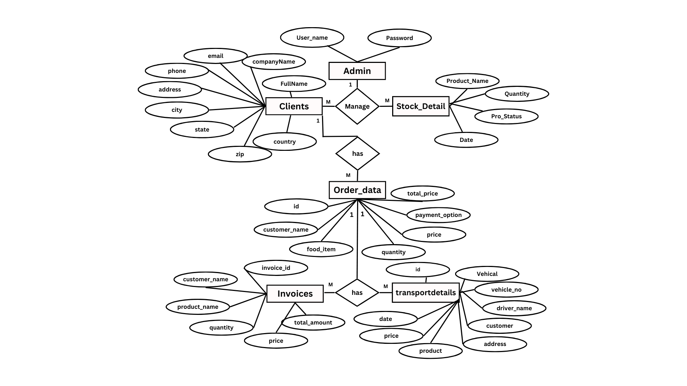

## 

Figure 1 Entity Relationship Diagram

## 3.2 Data Flow Diagram

## 

Figure 2 Data Flow Diagram

## 3.3 Use Case Diagram

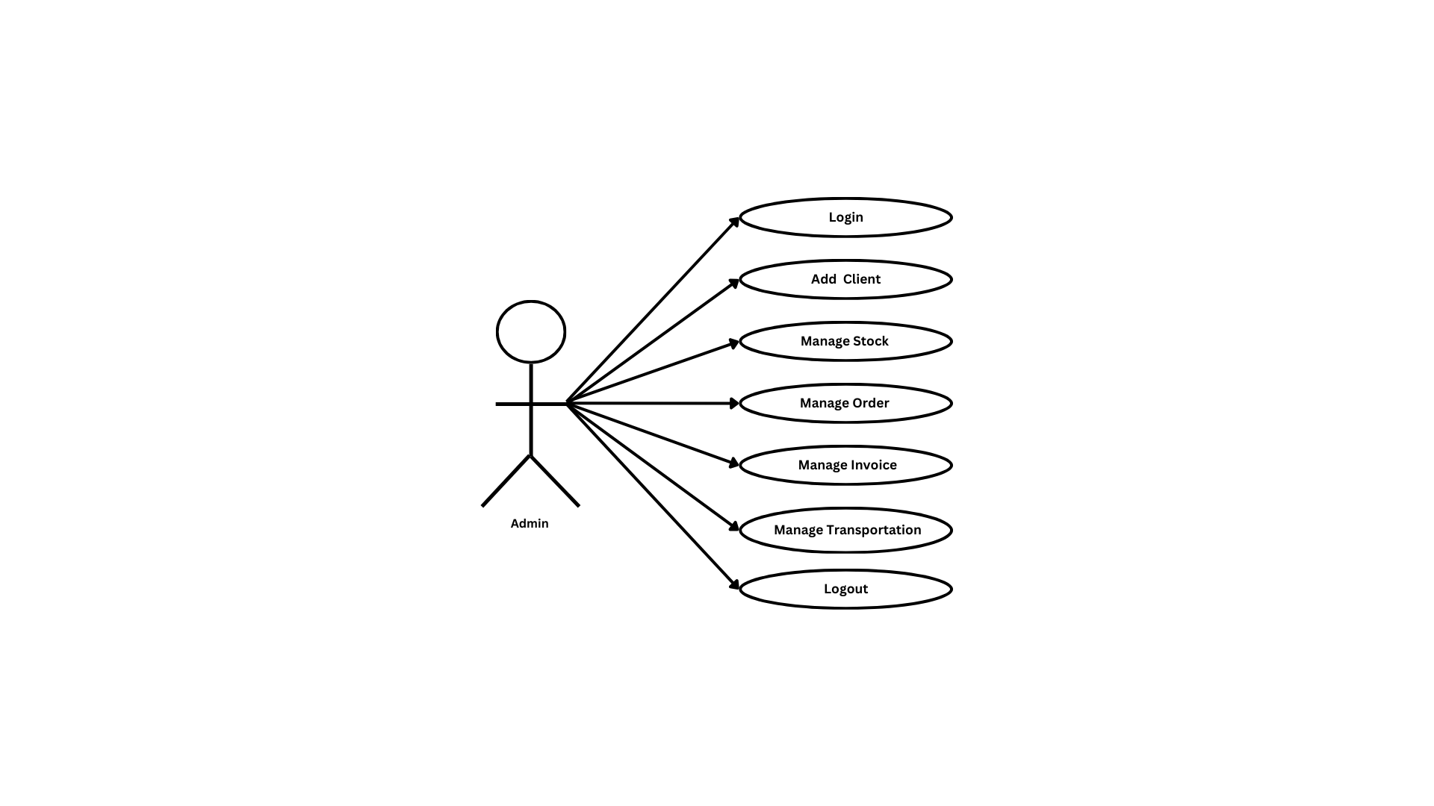

Figure 3 Use Case Diagram

## 3.4 Class Diagram

## 

Figure 4 Class Diagram

## 3.5 Activity Diagram

### **3.5.1 Add client**

## 

Figure 5.1 Add client

### 

### **3.5.2 View Invoice**

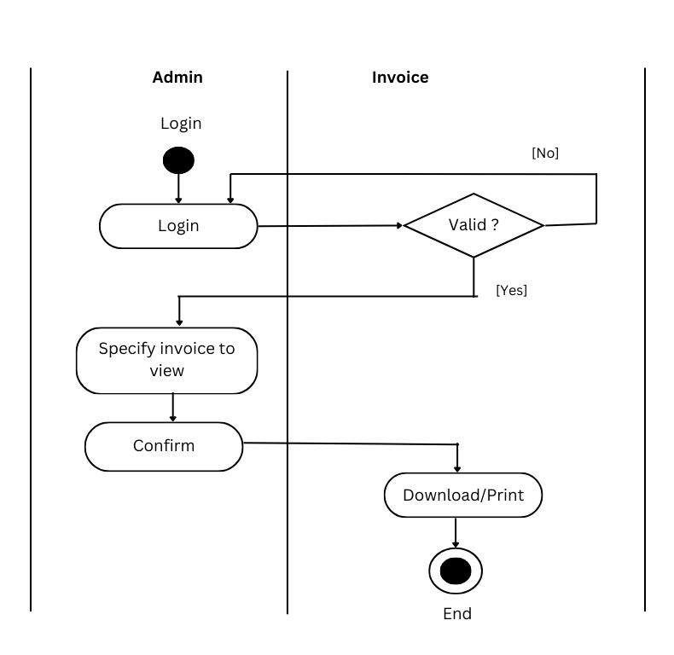

Figure 5.2 View Invoice

## 3.6 Sequence Diagrams

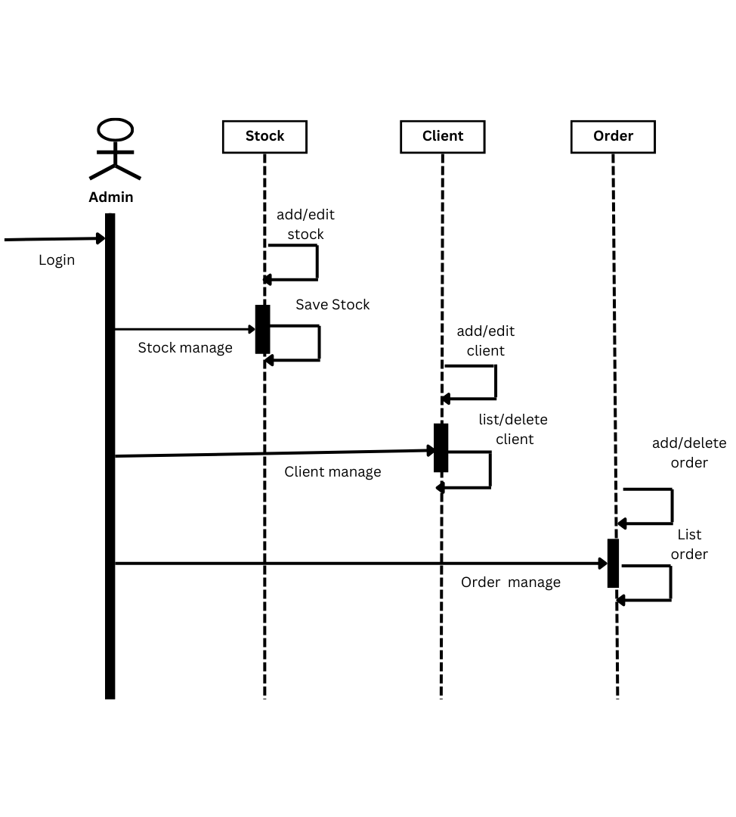

Figure 6 Sequence Diagrams

## 3.7 Component Diagrams

## 

Figure 7 Component Diagrams

## 3.8 Deployment Diagram

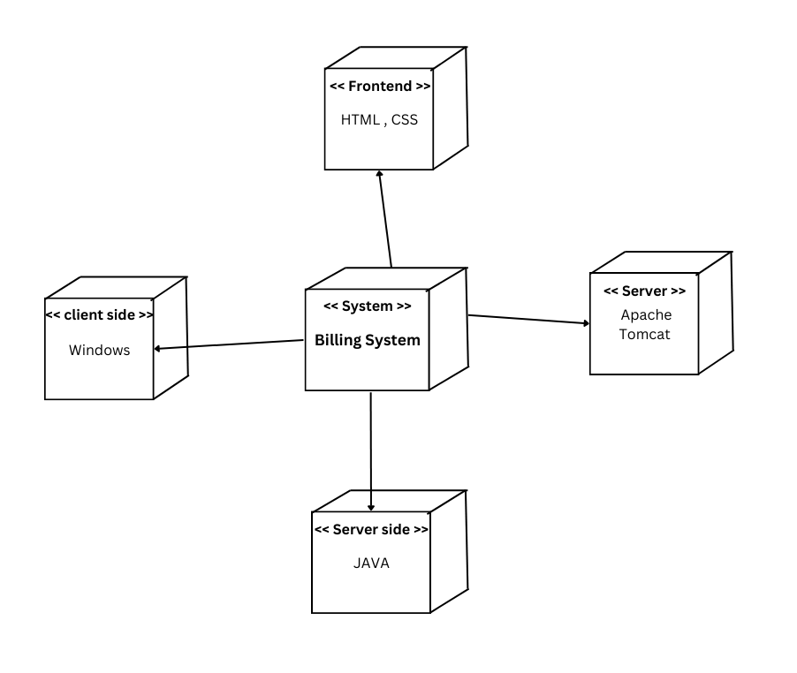

Figure 8 Deployment Diagram

## 3.9 Data Dictionary

## 

Figure 9 Clients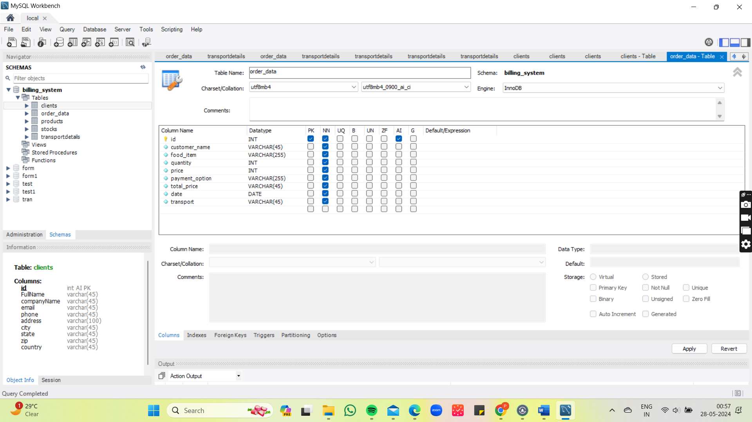

Figure 10 Order Data

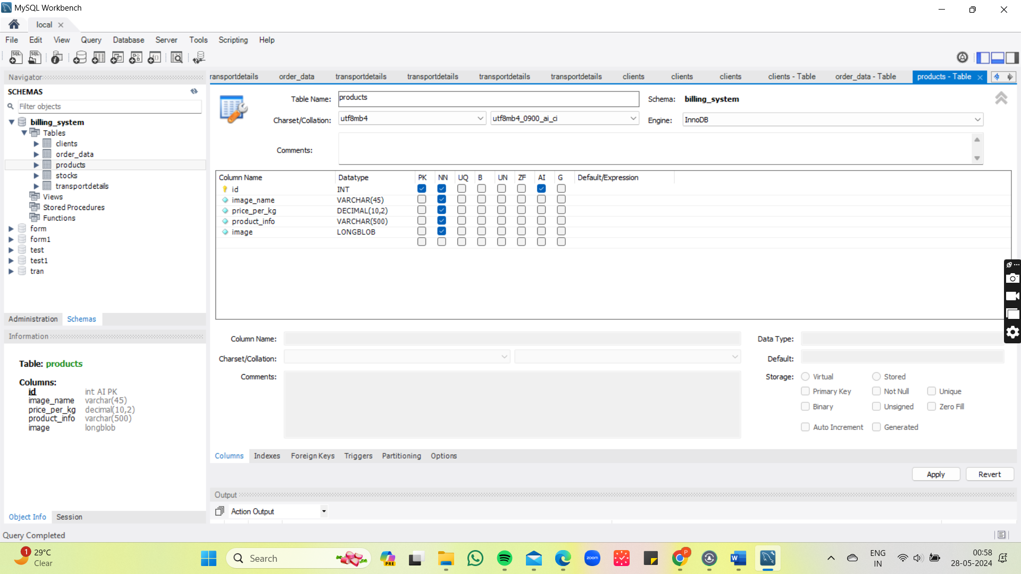

Figure 11 Products

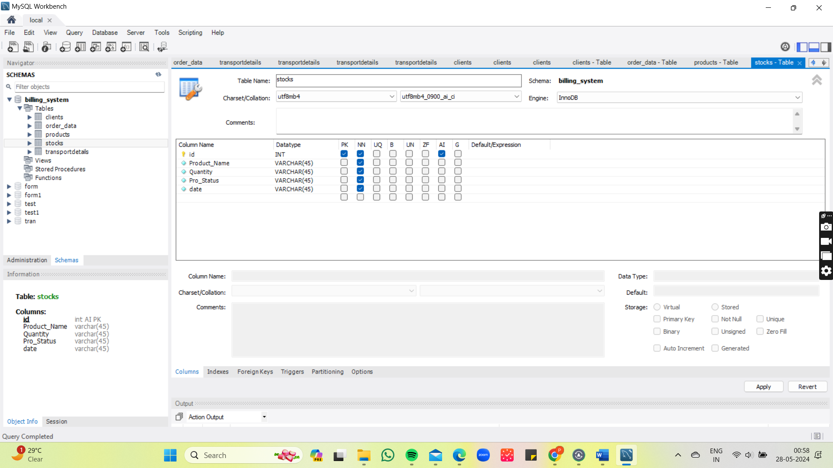

Figure 12 Stocks

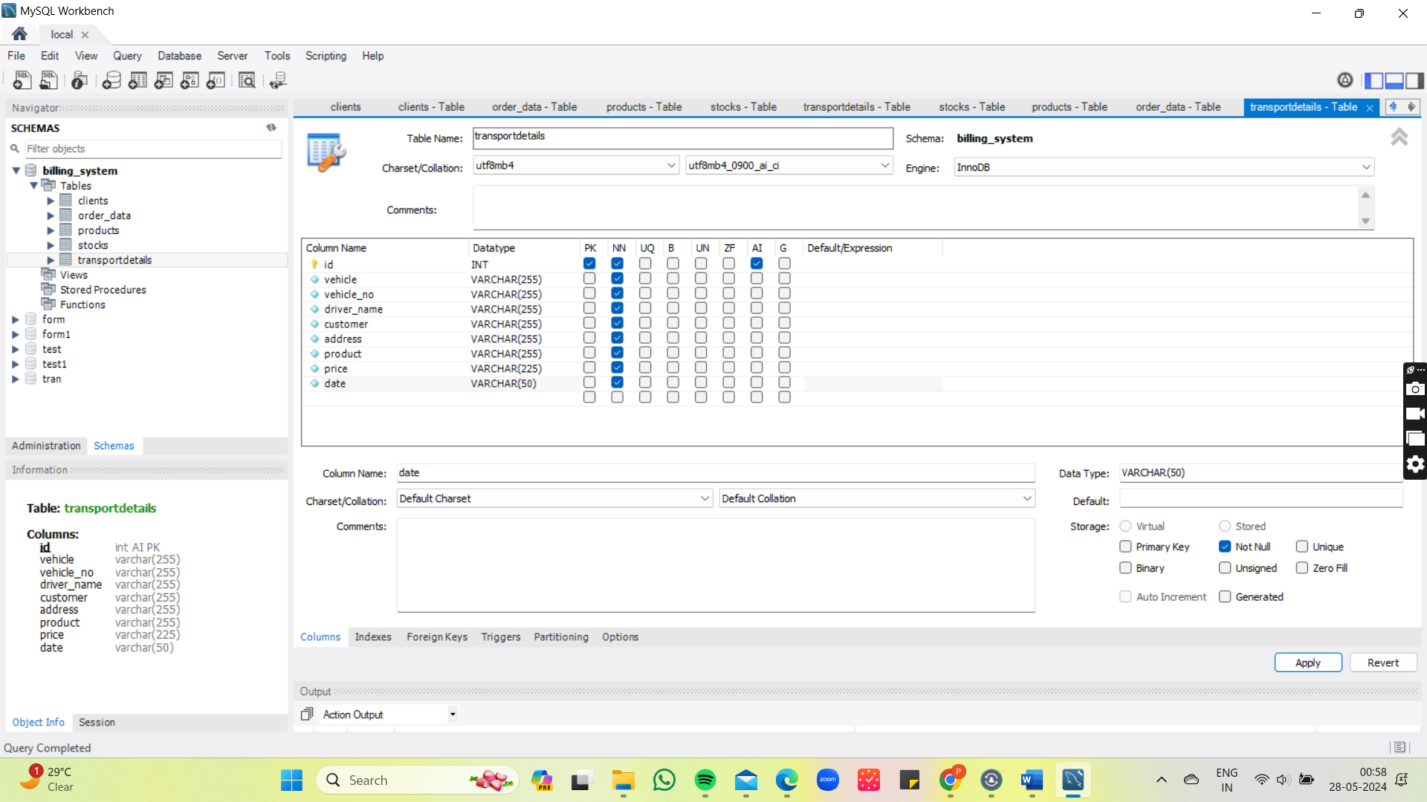

Figure 13 Transport Detail

**Chapter 4**

# **Test Procedure and Implementation**

Testing procedures are essential to ensure that a product, system, or software performs as expected and meets specified requirements. Below is a general outline of a comprehensive testing procedure:

## 4.1. Preparation and Planning

### **4.1.1 Define Objectives**

- Identify the purpose and scope of the testing.

- Determine the specific goals and requirements to be met.

### **4.1.2 Develop a Test Plan**

- Outline the testing strategy.

- Specify the resources needed (e.g., personnel, tools, and environments).

- Define the schedule and milestones.

### **4.1.3 Identify Test Items**

- List the items to be tested (e.g., software features, hardware components).

- Define their interdependencies.

### **4.1.4 Risk Analysis**

- Assess potential risks and their impact on the testing process.

- Plan for mitigation strategies.

## 4.2. Designing Tests

### **4.2.1 Create Test Cases**

- Develop detailed test cases with specific inputs, execution steps, and expected results.

- Ensure test cases cover all functional and non-functional requirements.

**Example-**

**Test case for Login:**

Form Ref: User Login

Functional Specification: Data validations

Test Objective: To check whether the valid data entered stored

Test Data: - Entering correct data in Mobile no, email, captcha code, term and condition

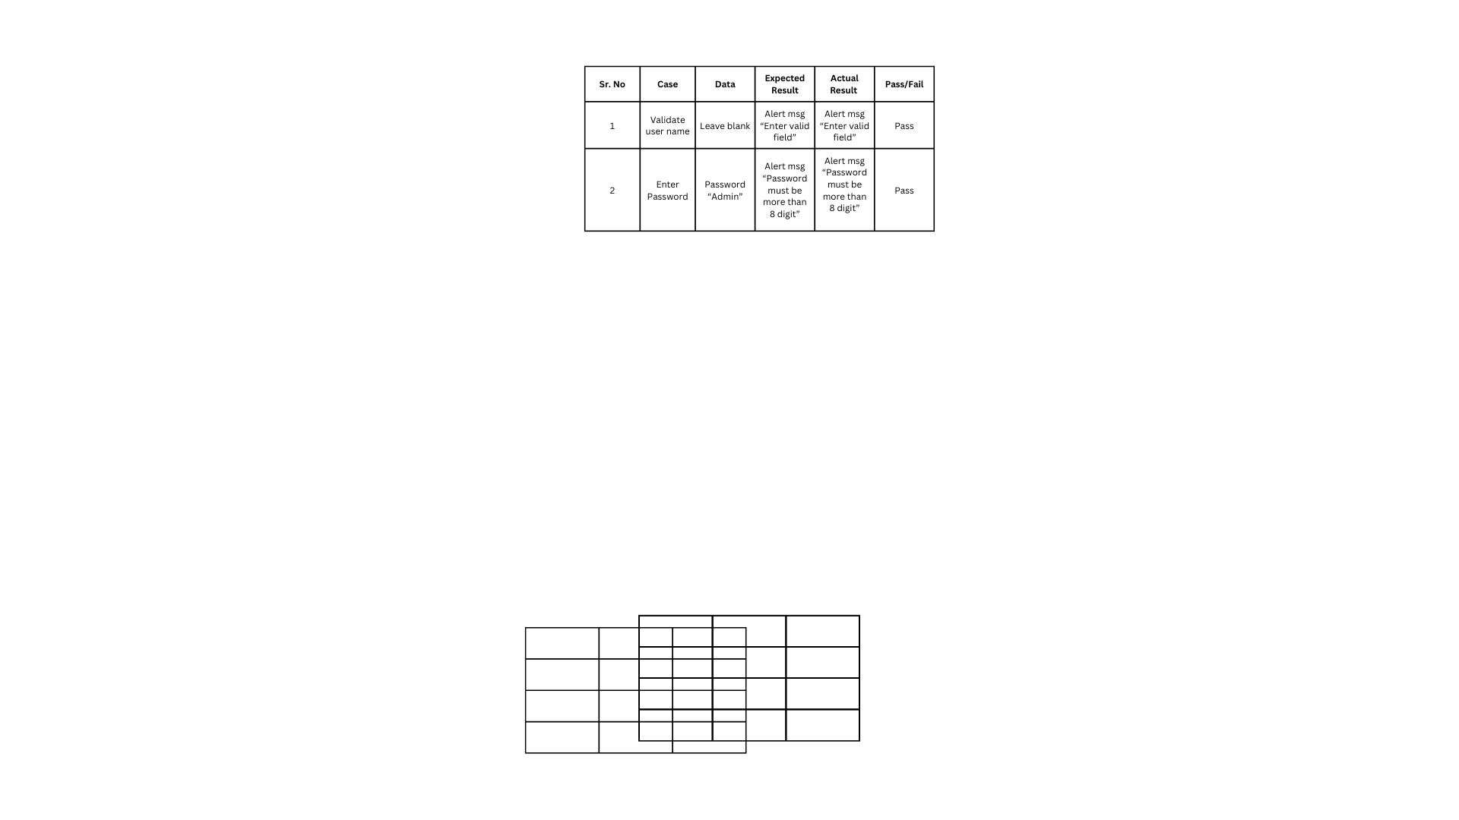

Figure 14 Test case For User Login

**Test case for Product**

Form Ref: Add Product

Functional Specification: Data Validation and Restriction

Test Objective: To check whether the valid data entered

Test Data: - Entering correct data in numeric field.

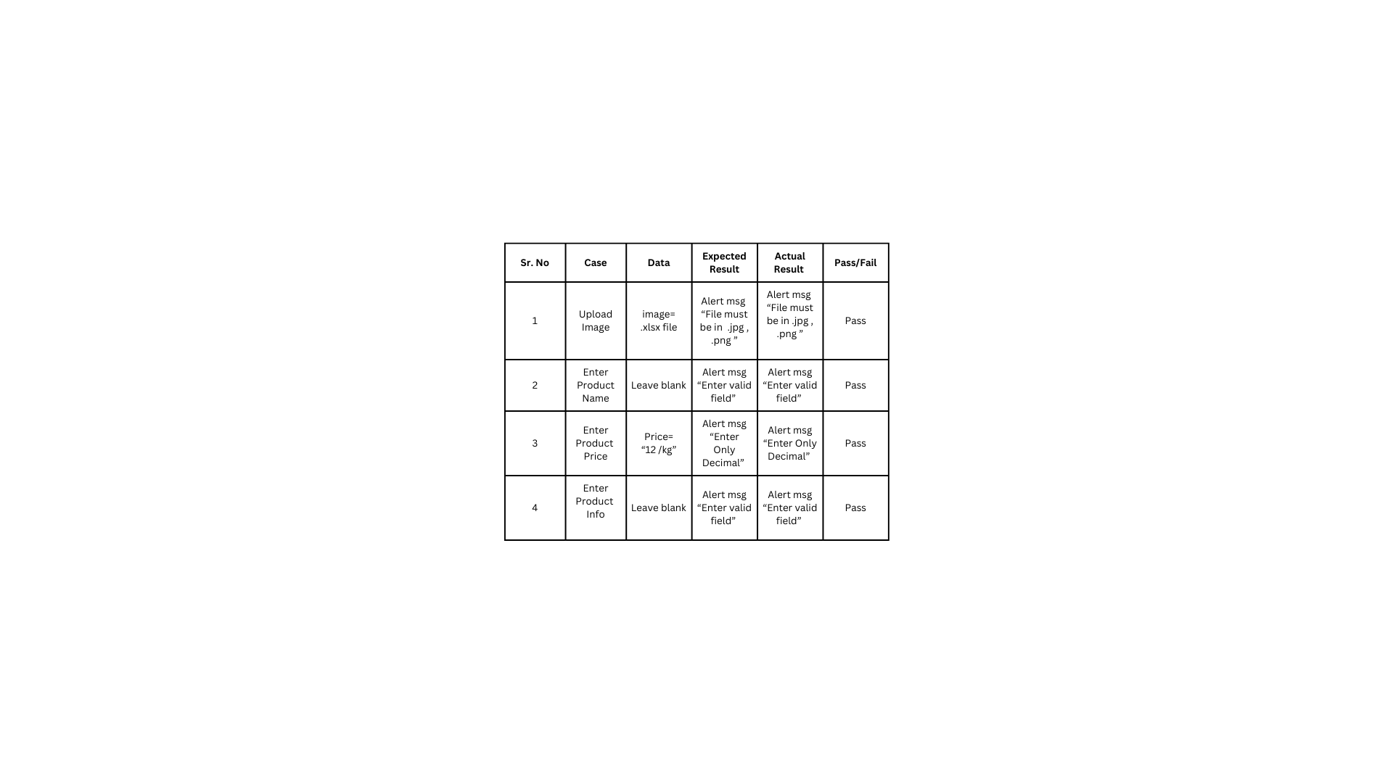

Figure 15 Test case For Add Product

### **4.2.2 Develop Test Scripts**

- Write automated test scripts if applicable.

- Ensure they are maintainable and reusable.

### **4.2.3 Prepare Test Data**

- Generate or identify data required for testing.

- Ensure the data is representative of real-world usage.

## 4.3. Setting Up the Test Environment

### **4.3.1 Configure Test Environment**

- Set up hardware, software, network configurations, and any other necessary components.

- Ensure the environment simulates the production environment as closely as possible.

### **4.3.2 Verify Environment Readiness**

- Perform checks to confirm that the test environment is functioning correctly.

- Validate that all necessary tools and resources are accessible.

## 4.4. Executing Tests

### **4.4.1 Perform Tests**

- Execute the test cases according to the test plan.

- Log test results, including any deviations from expected results.

### **4.4.2 Monitor Testing**

- Continuously monitor the testing process for issues or bottlenecks.

- Adjust test cases and environment as needed.

## 4.5. Analyzing Results

### **4.5.1 Evaluate Test Results**

- Compare actual results with expected results.

- Document any defects or discrepancies.

### **4.5.2 Perform Root Cause Analysis**

- Investigate the cause of any defects.

- Determine whether the issue is with the test case, environment, or the product itself.

## 4.6. Reporting

### **4.6.1 Document Findings**

- Compile a detailed test report.

- Include test case results, defect summaries, and overall assessment of the product.

### **4.6.2 Communicate Results**

- Share findings with stakeholders.

- Provide recommendations for improvements or further testing.

## 4.7. Post-Testing Activities

### **4.7.1 Retesting and Regression Testing**

- Address any defects found and perform retesting.

- Conduct regression testing to ensure that changes have not affected existing functionality.

### **4.7.2 Test Closure**

- Ensure all planned tests are executed and objectives are met.

- Archive test cases, scripts, and data for future reference.

- Conduct a review meeting to gather feedback and improve future testing processes.

## 4.8. Continuous Improvement

### **4.8.1 Analyze Metrics**

- Evaluate testing metrics to identify areas for improvement.

- Refine test cases, tools, and processes based on lessons learned.

### **4.8.2 Update Test Plan**

- Modify the test plan to incorporate improvements and address new requirements**.**

**Chapter 5**

# **SCREENSHOT**

## 5.1 Login:

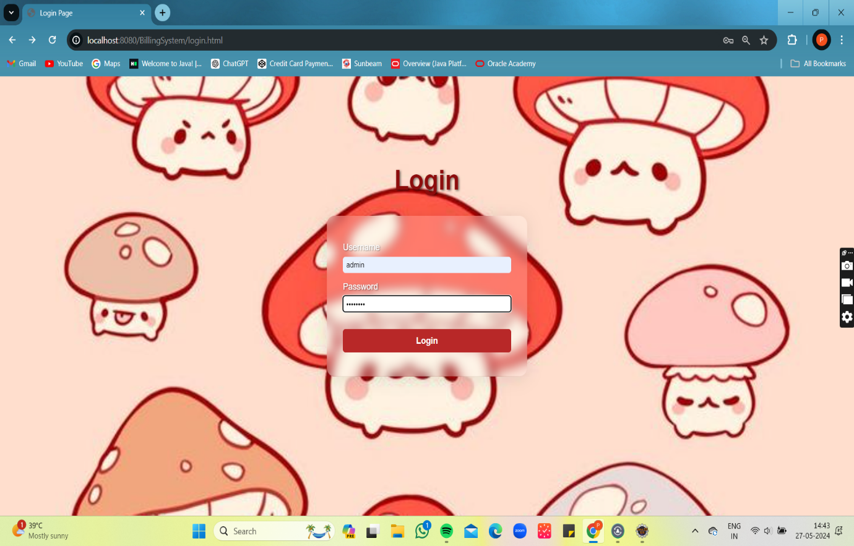

Figure 16 Login

## 5.2 Home Page:

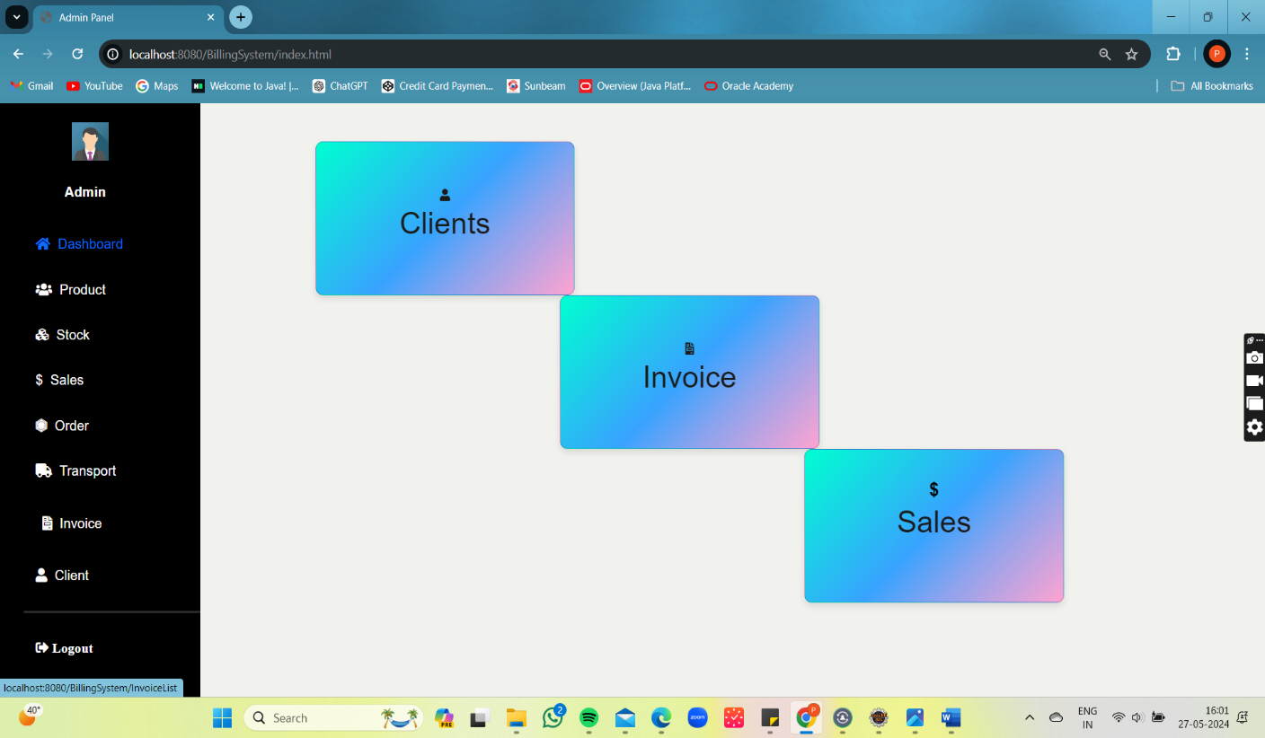

Figure 17 Home Page

## 5.3 Vertical Navigation Bar:

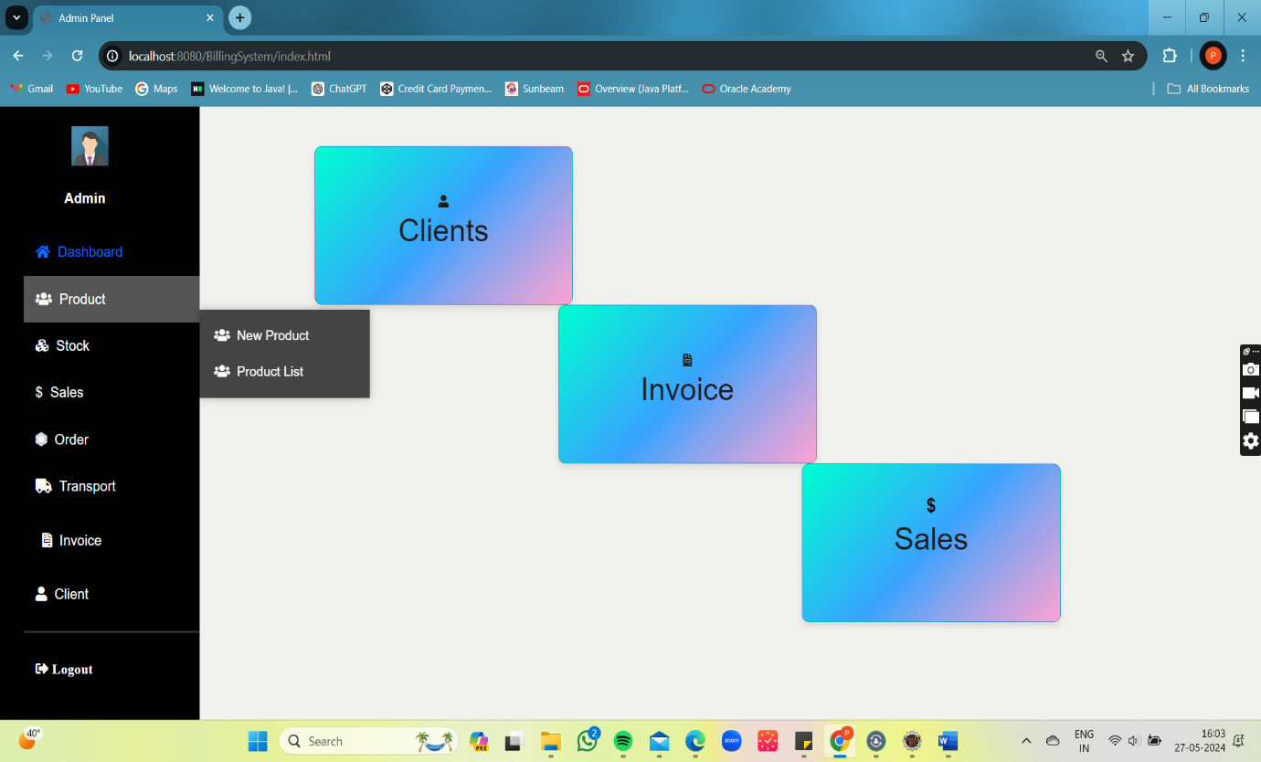

Figure 18 Vertical Navigation Bar

## 5.4 Product Page:

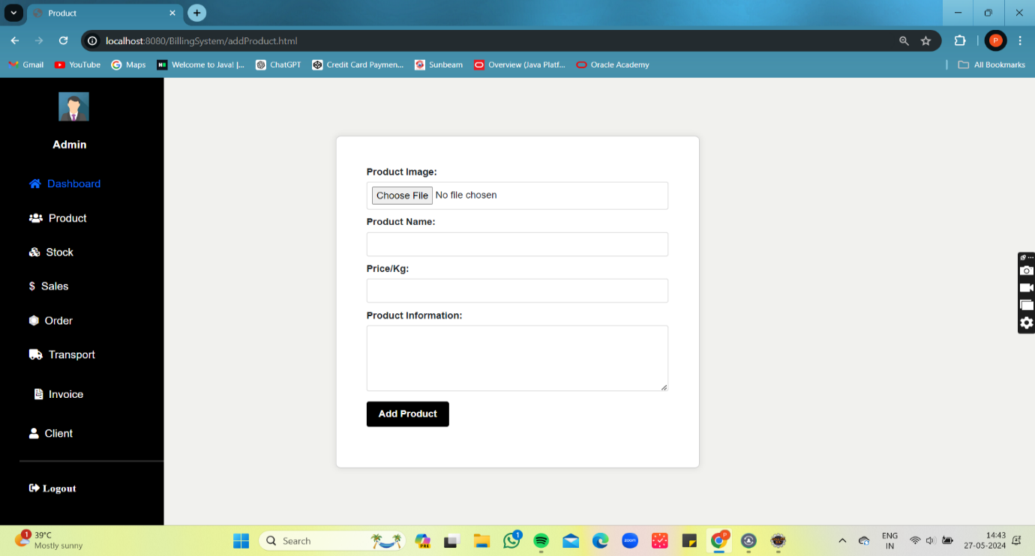

Figure 19 Product Page

## 5.5 Product Validation:

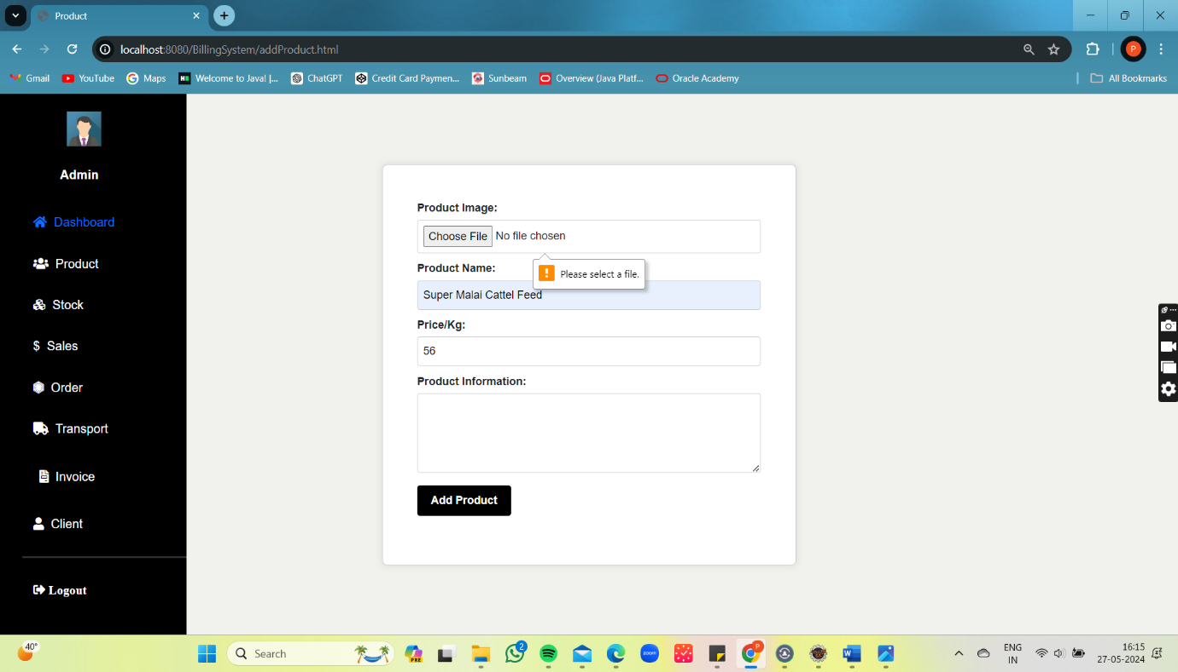

Figure 10 Product Validation

## 5.6 Add Product :

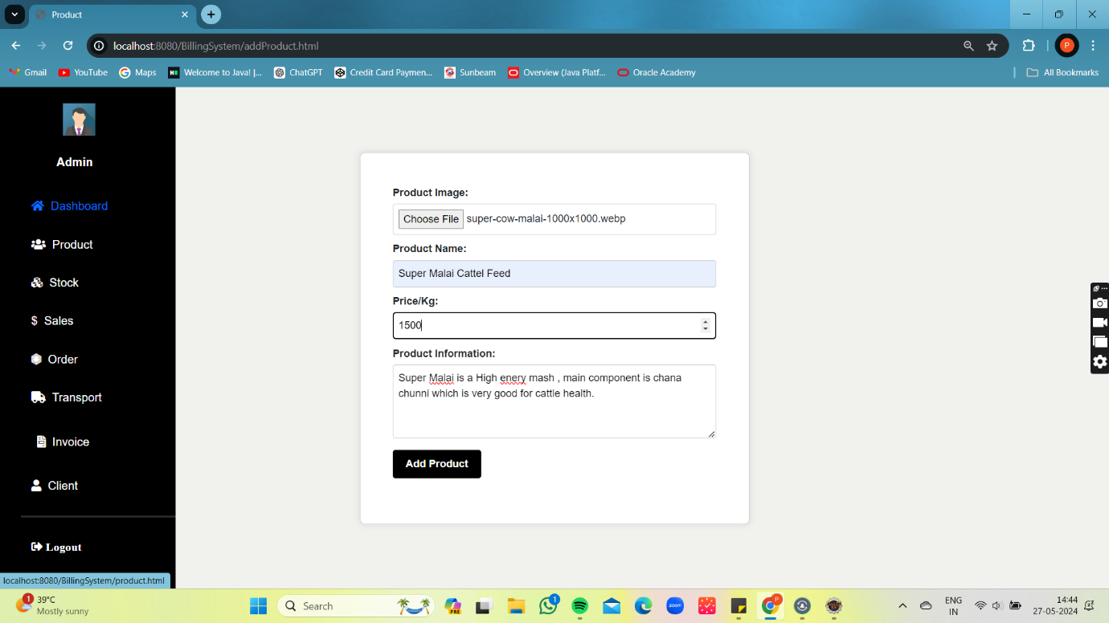

Figure 21 Add Product

## 5.7 Product List:

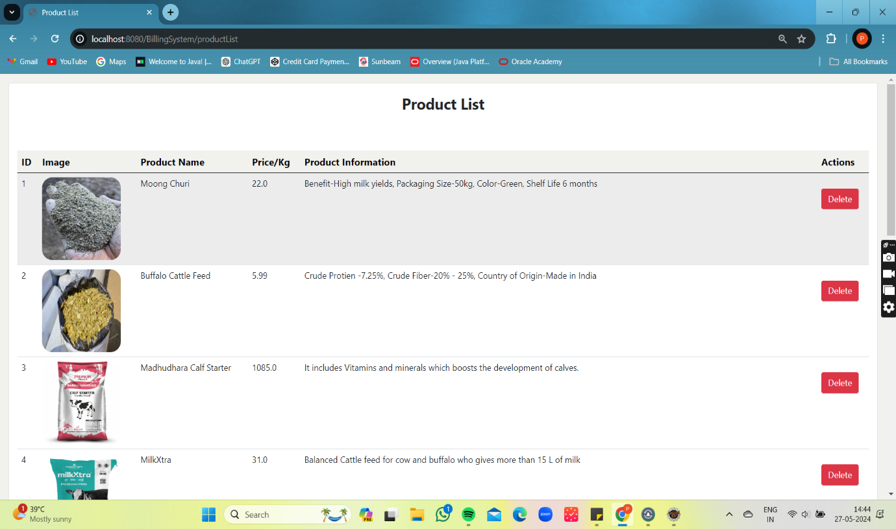

Figure 22 Product List

## 5.8 Stock Detail:

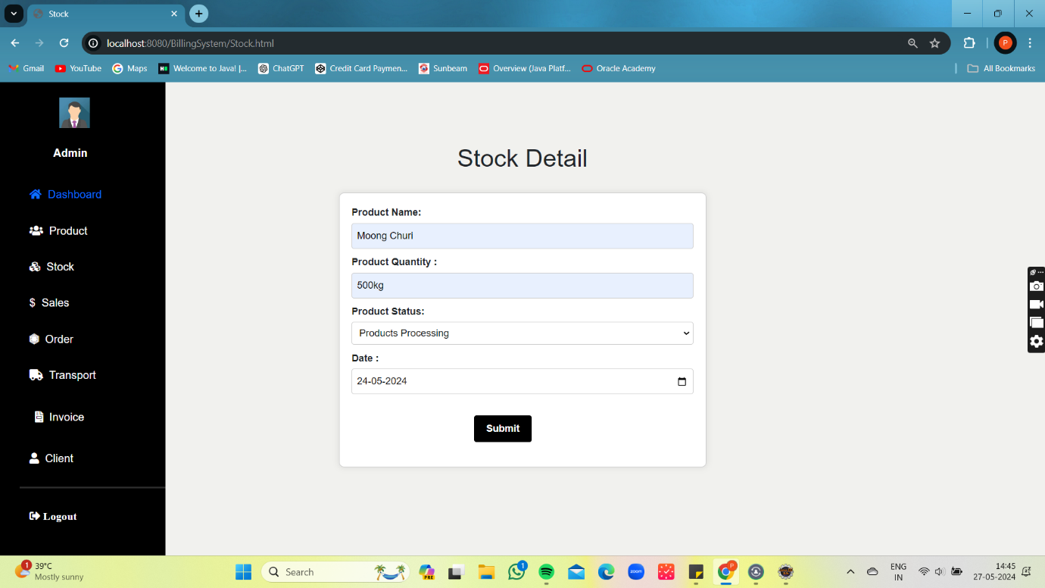

Figure 23 Stock Detail

## 5.9 Stock List:

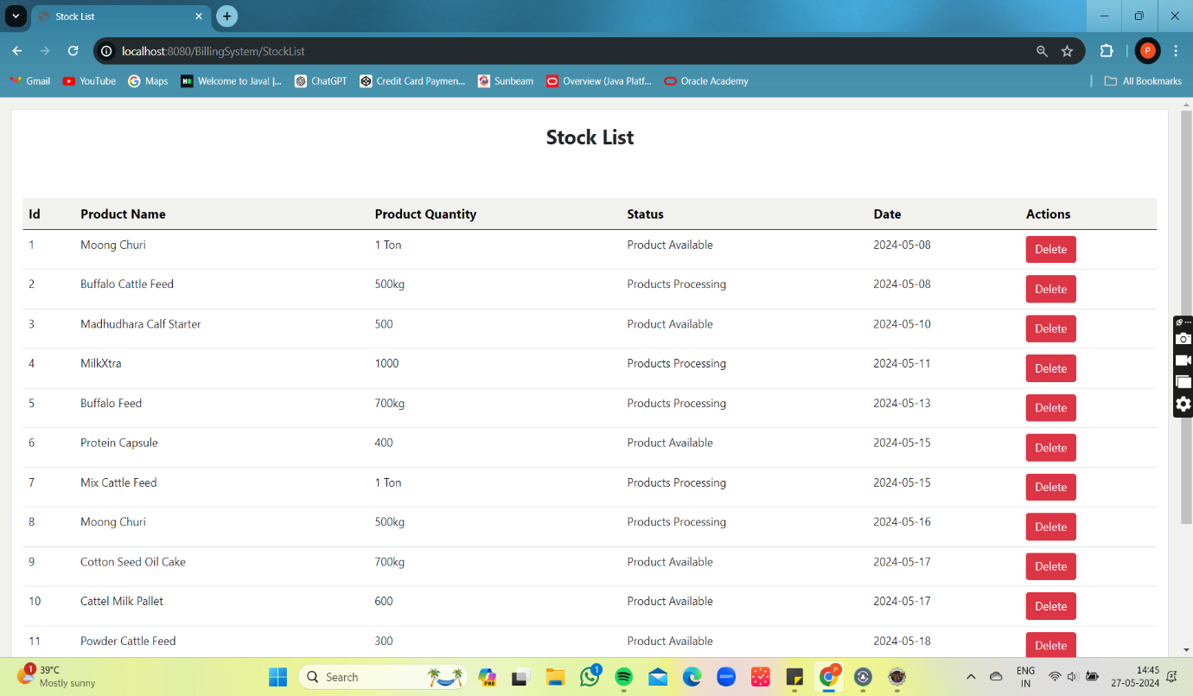

Figure 24 Stock List

## 5.10 Monthly Sales:

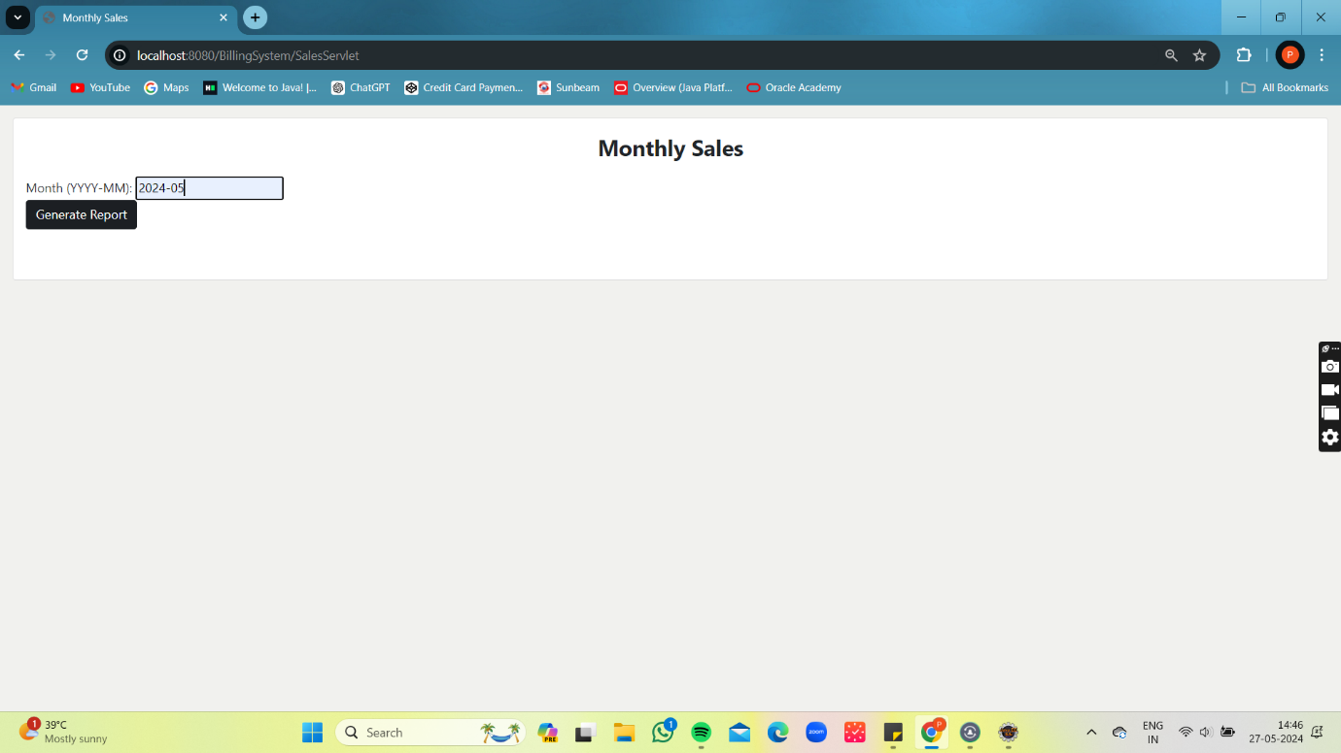

Figure 25 Monthly Sales

## 5.11 Monthly Sales List:

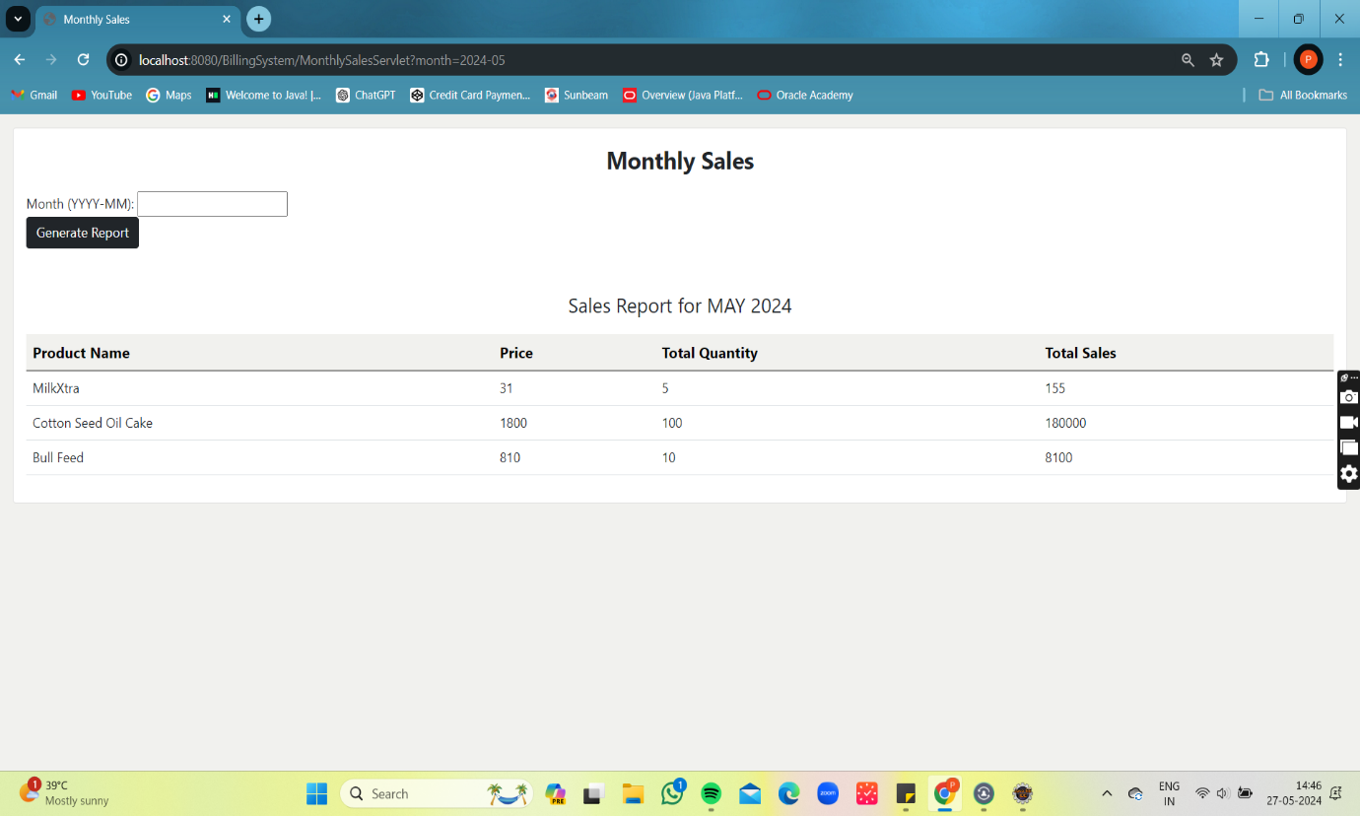

Figure 26 Monthly Sales List

## 5.12 Order Page:

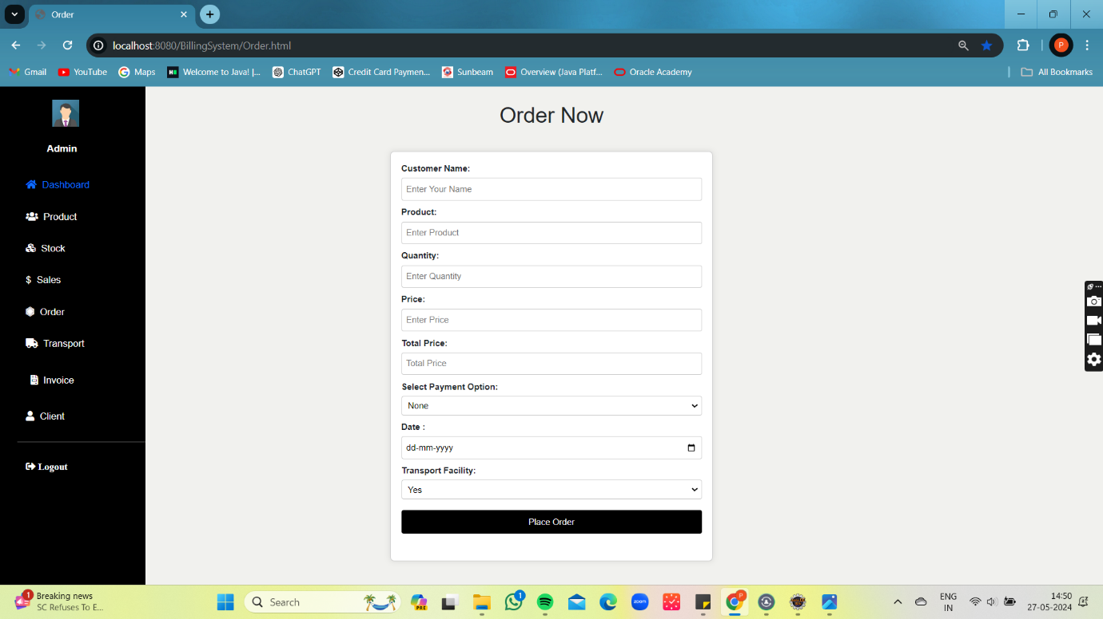

Figure 27 Order Page

## 5.13 Add Order:

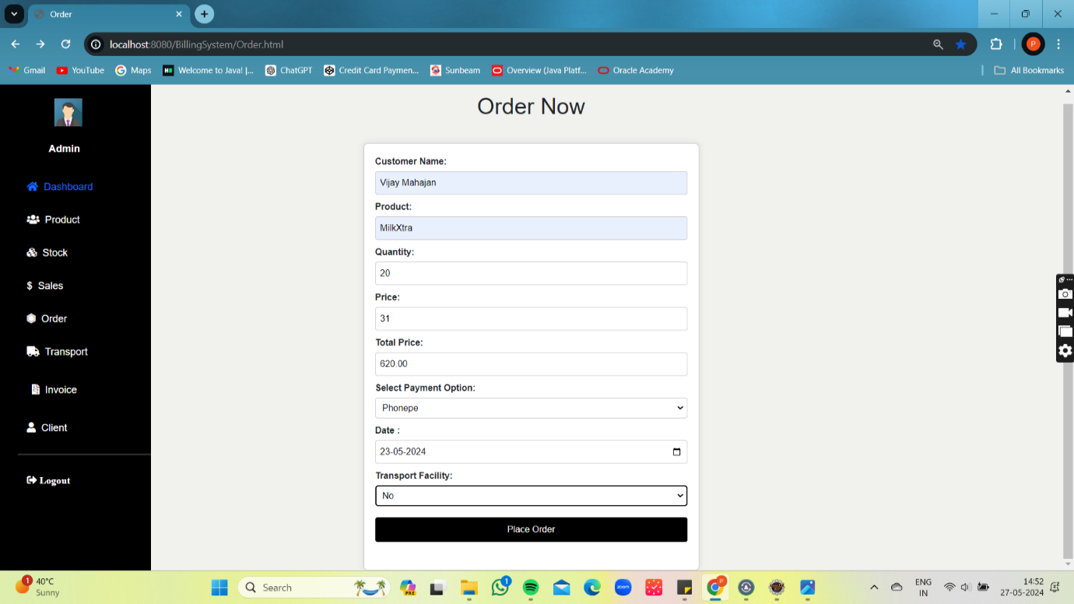

Figure 28 Add Order

## 5.14 Order List :

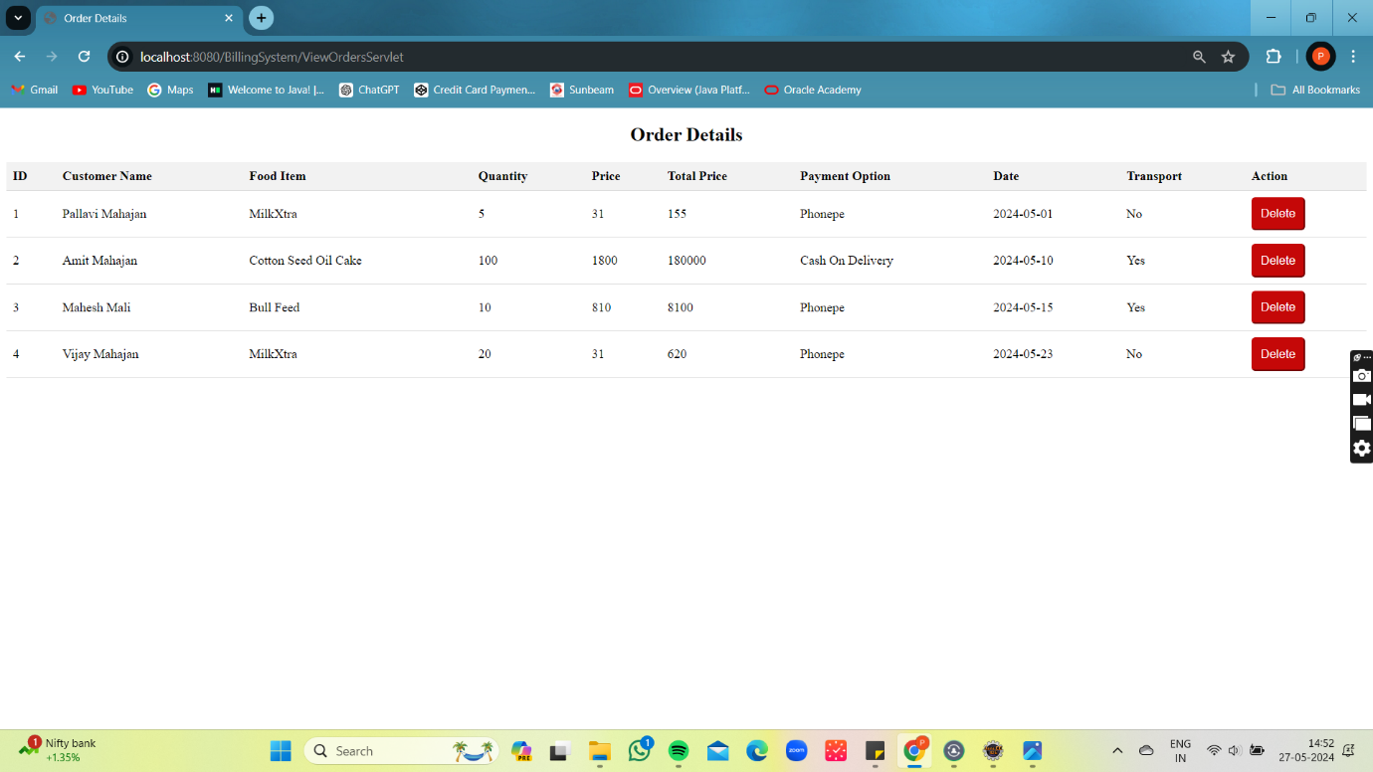

Figure 29 oder List

## 5.15 Delete Order :

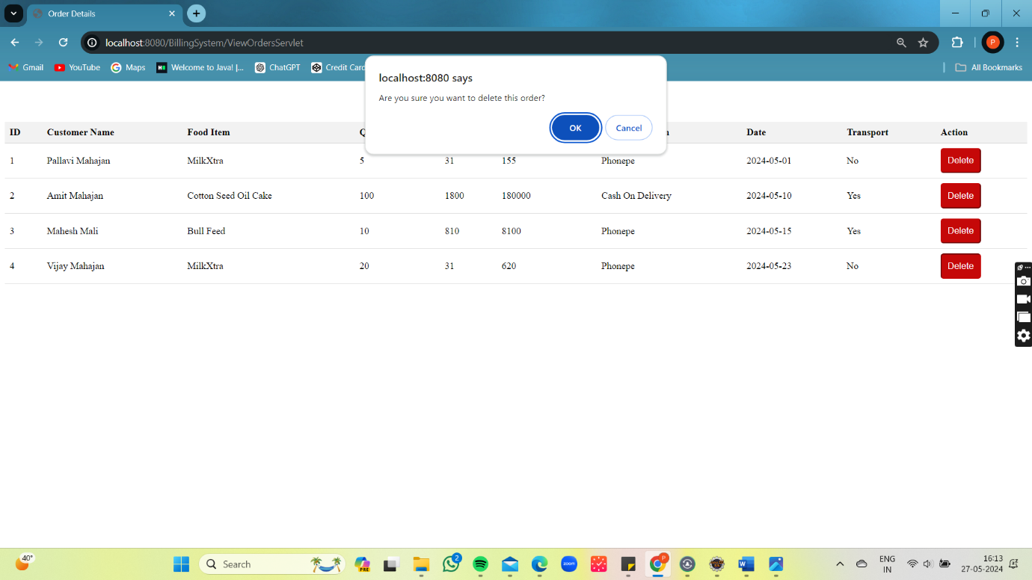

Figure 30 Delete Order

## 5.16 Add Trensport:

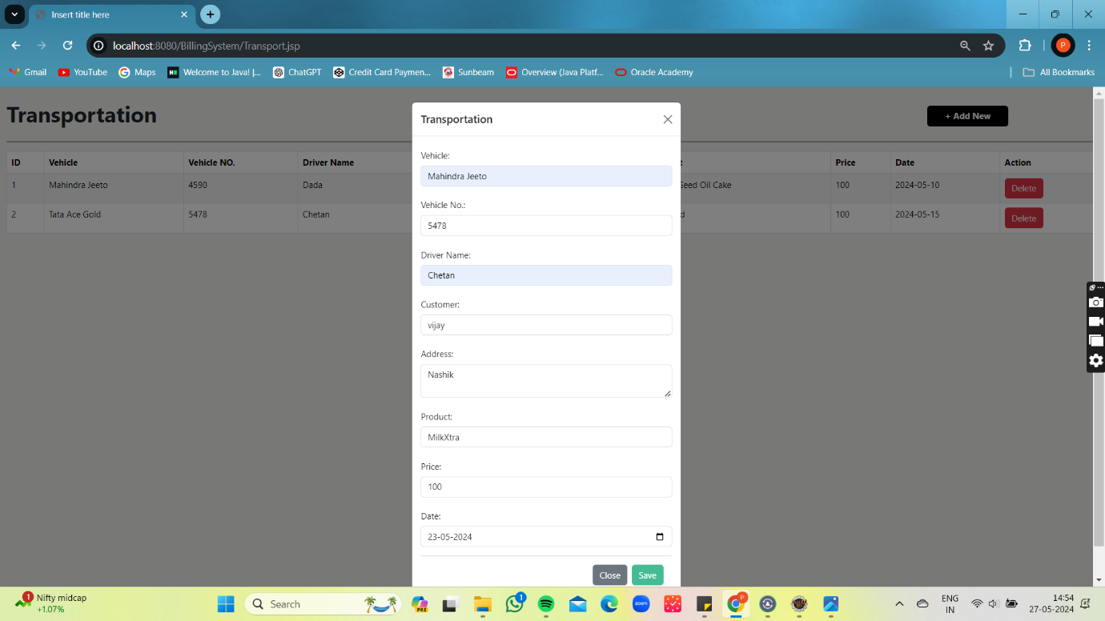

Figure 31 Add Trensport

## 5.17 Transport List:

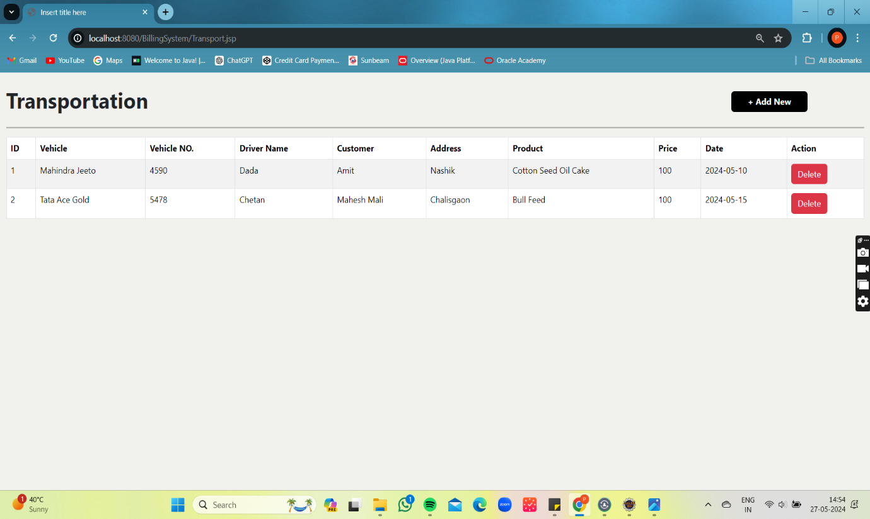

Figure 32 Transport List

## 5.18 Invoice List:

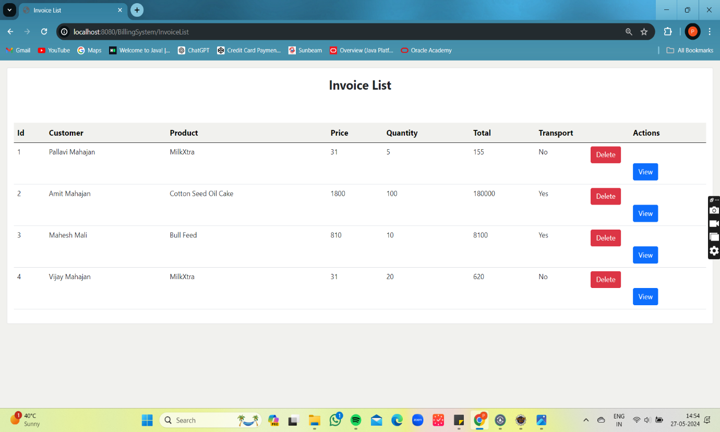

Figure 33 Invoice List

## 5.19 Invoice :

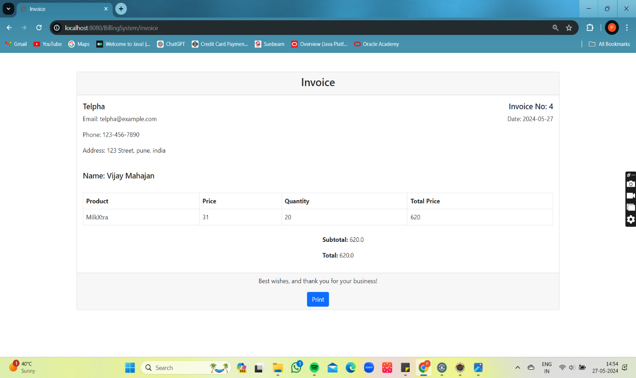

Figure 34 Invoice

## 5.20 Download Invoice :

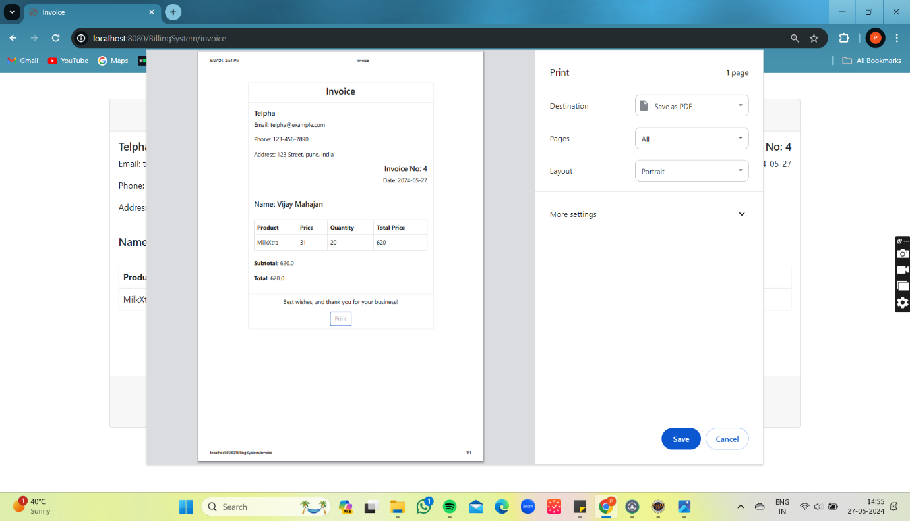

Figure 35 11 Download Invoice

## 5.21 Add Client:

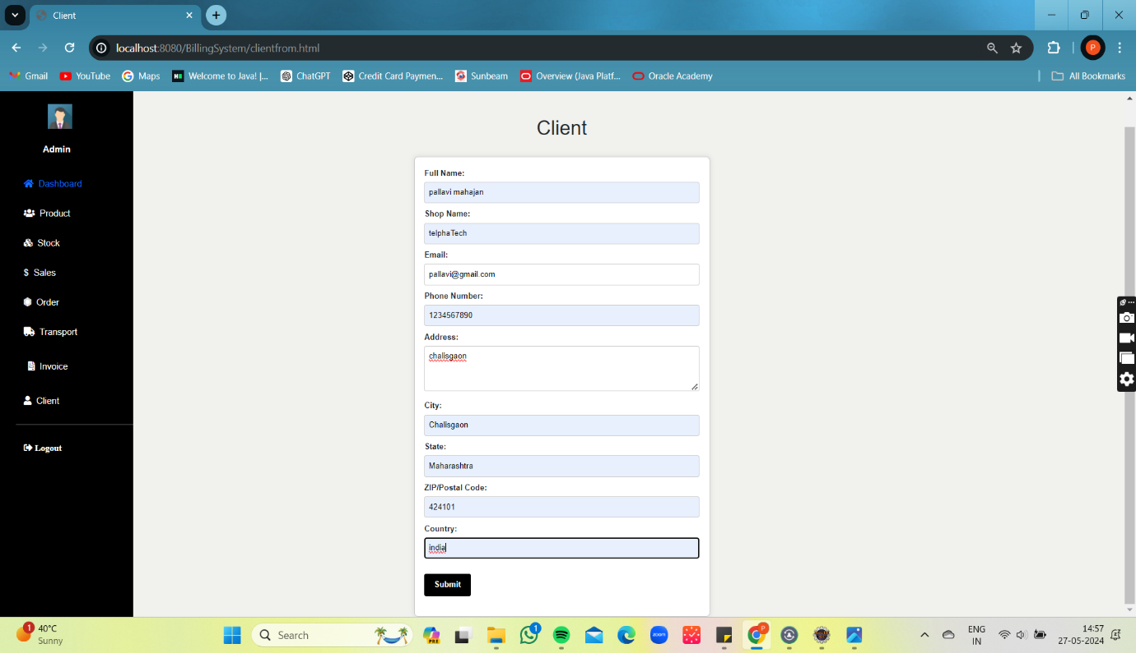

Figure 36 Add Client

## 5.22 Client List:

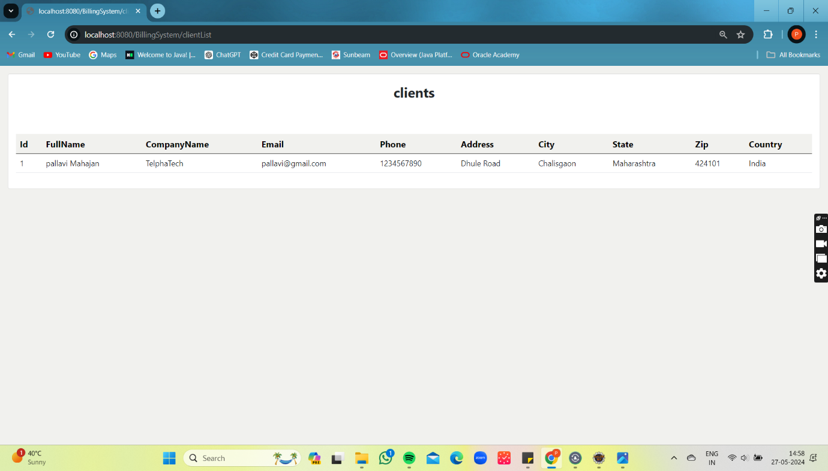

Figure 37 Client List

## 5.23 Logout:

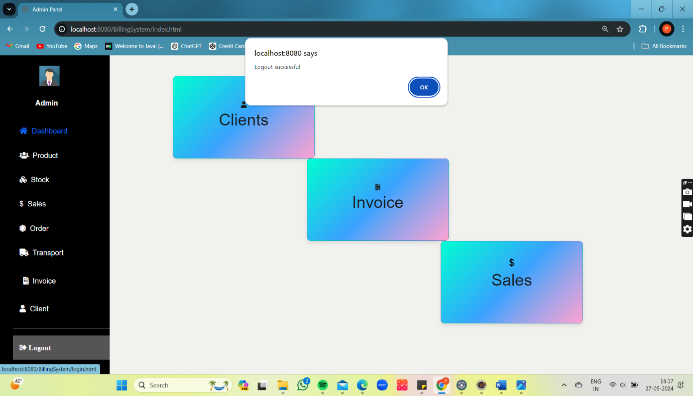

Figure 38 Logout

**Chapter 6**

# **Limitations and Future Enhancement**

## 6.1 Limitations:

* The system will not handle complex accounting functions beyond basic invoicing and payment tracking.
* Customization options may be limited to predefined templates and configurations.
* Security measures will be implemented, but absolute protection against all potential threats cannot be guaranteed.
* Continuous improvement and updates may introduce temporary disruptions or changes in functionality.

## 6.2 Future Enhancement

Enhancing a billing system involves integrating advanced technologies and improving current processes to increase efficiency, accuracy, and customer satisfaction. Here are several future enhancements that could be made to a billing system:

### **Mobile and Cloud Integration**

* + **Mobile Access:** Develop mobile-friendly billing applications to allow customers and employees to manage billing on the go.
  + **Cloud-Based Solutions:** Migrate to cloud-based billing systems for scalability, flexibility, and real-time access to billing information from anywhere.

### **Customer Self-Service Portals**

* **Interactive Portals:**Create self-service portals where customers can view, download, and pay their bills, update their payment information, and resolve billing issues independently.
* **Chatbots and Virtual Assistants:** Implement chatbots to assist customers with common billing queries, providing instant support and reducing the load on customer service teams.

**Chapter 7**

# **CONCLUSION**

In conclusion, the billing system outlined in this project offers a robust and adaptable solution tailored to the modern needs of businesses. Beyond the core functionalities highlighted in the abstract, it's important to note additional benefits and considerations.

Firstly, the system's scalability ensures that it can accommodate businesses of various sizes and industries, from startups to large enterprises. Whether handling a few transactions or managing high volumes of financial data, the system's architecture is designed to scale accordingly, providing flexibility and resilience.

Furthermore, the implementation of stringent security measures safeguards sensitive financial information, ensuring compliance with regulatory requirements and instilling trust among users. Data encryption, access controls, and regular security audits are among the measures employed to mitigate risks and protect against potential threats.

Moreover, the system's adaptability allows for seamless integration with existing software and third-party applications, facilitating interoperability and enhancing workflow efficiency. Whether integrating with accounting software, customer relationship management (CRM) systems, or e-commerce platforms, the billing system can be customized to suit specific business requirements.

Lastly, ongoing support and maintenance are essential components of the system's lifecycle, ensuring continued functionality and optimization. Regular updates, technical assistance, and user training contribute to long-term success and user satisfaction.

In summary, the billing system not only streamlines financial processes but also offers scalability, security, interoperability, and ongoing support, positioning it as a valuable asset for businesses seeking to optimize their operations and drive growth in today's dynamic marketplace.

**Chapter 8**

# **BIBLIOGRAPHY AND REFERENCE**

## 8.1 Books Used:

1. "HTML and CSS: Design and Build Websites" by Jon Duckett.
2. Flanagan, D. (2018). "JavaScript: The Definitive Guide."
3. Sierra, K., & Bates, B. (2018). "Head First Java."

## 8.2 References Used:

1. Oracle. "Java SE Documentation." Retrieved from <https://docs.oracle.com/javase/>
2. MDN. "JavaScript." Retrieved from <https://developer.mozilla.org/en-US/docs/Web/JavaScript>
3. Bootstrap Documentation. Retrieved from <https://getbootstrap.com/docs/5.1/getting-started/introduction/>
4. https://www.javatpoint.com/java-tutorial